Mastering Container Gardening: Advanced Techniques for Thriving Plants in Any Space

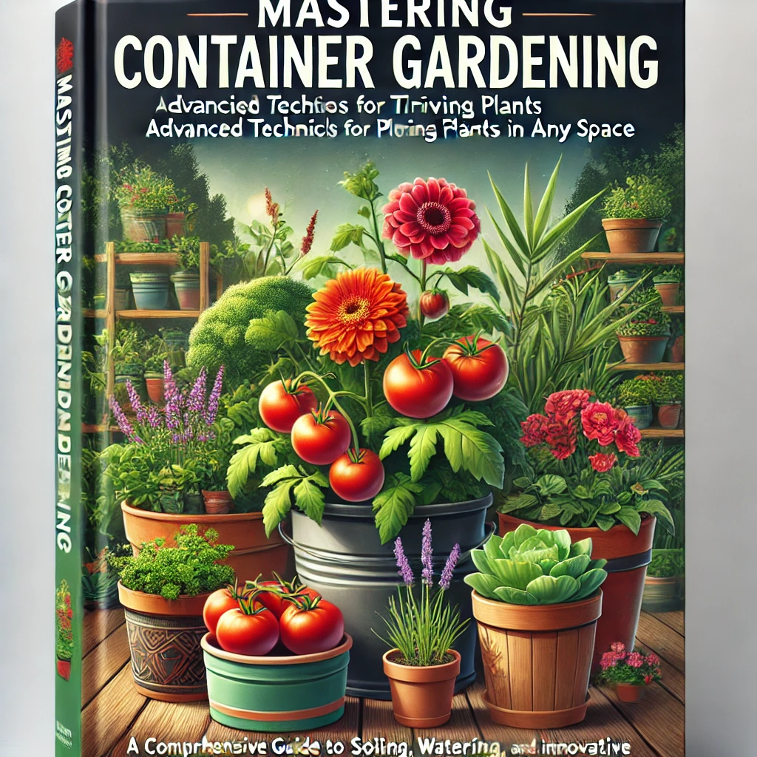

By: William Woolverton
A Comprehensive Guide to Soil, Watering, Plant Selection, and Innovative Methods for Year-Round Success
Dedication:

I want to dedicate this book to my little buddy, my grandson Tyler. I don’t know how many years I’ll get to be in your life, but with the good Lords blessings, a whole lot more.
At the time of writing this, you are around the age I was when I would go look for my grandpop on my mom’s side, just like you, out in the garden. It’s one of my favorite memories and the things he shared and taught me. I wanted to make sure I shared it with you as well. Your great, great, grandpop was a very intelligent and kind man. Plus, he knew how to do or make anything. He hung the moon for me and I hope I will hung the moon for you.
Love always,
Grandpop

Legal Information

Copyright © 2024 by William F. Woolverton
All rights reserved. No part of this book may be reproduced or transmitted in any form or by any means, electronic or mechanical, including photocopying, recording, or by any information storage and retrieval system, without permission in writing from the publisher.
Published by: First Prince Marketing
1242 Main St.
Pleasant View, Tn. 37146

Contents
Chapter 1: Introduction to Container Gardening 8
1.1 Why Choose Container Gardening? 8
1.2 The Science Behind Container Gardening 10
1.3 Getting Started: Choosing Containers, Soil, and Plants 12
1.4 Practical Considerations for Container Gardening 14
1.5 The Aesthetic and Functional Flexibility of Container Gardening 16
Chapter 2: Mastering Container Selection and Preparation 17
2.1 The Science Behind Container Selection 18
2.3 Proper Drainage Techniques: Avoiding Overwatering 22
2.4 Choosing the Right Size and Material for Maximum Plant Growth 24
2.5 Preparing Containers for Planting: Step-by-Step 25
Conclusion: Mastering container selection and preparation 27
Chapter 3: Soil and Potting Mixes for Containers 28
3.2 Custom Potting Mixes for Containers 30
3.3 Understanding Soil pH and Nutrient Balance 32
Chapter 4: Plant Selection for Container Gardening 40
4.1 The Science of Plant Selection for Containers 41
4.2 Best Plants for Containers: Vegetables, Herbs, and Flowers 42
4.3 Combining Plants Effectively in Containers 46
4.4 Choosing Plants Based on Climate and Sunlight Conditions 48
Conclusion: Choosing the right plants for container gardening 51
Chapter 5: Watering and Irrigation Techniques for Container Gardens 52
5.1 The Science of Watering: Understanding Plant Water Needs 53
5.2 Proper Watering Techniques for Containers 54
5.3 Avoiding Common Watering Mistakes 55
5.4 Self-Watering Container Systems 57
5.5 Dealing with Overwatering and Underwatering Issues 59
5.6 Watering in Special Conditions: Climate, Plant Type, and Location 61
Chapter 6: Fertilizing and Plant Nutrition for Container Gardens 65
6.1 The Science of Plant Nutrition in Containers 66
6.2 Types of Fertilizers for Container Plants 67
6.3 Fertilization Schedules and Techniques 70
6.4 Organic vs. Synthetic Fertilizers: Pros and Cons 72
6.5 Monitoring Plant Nutrition and Correcting Deficiencies 74
Conclusion: Fertilizing container plants requires a balanced approach 77
Chapter 7: Pruning and Maintenance for Container Plants 78
7.3 Root Pruning for Container Plants 84
7.5 Dealing with Common Container Plant Issues 87
Conclusion: Pruning, root maintenance, and routine care are essential tasks 89
Chapter 8: Season Extension Techniques for Container Gardening 90
8.1 The Science Behind Season Extension 91
8.3 Greenhouses: A Versatile Option for Extending the Growing Season 94
8.4 Overwintering Container Plants 95
Chapter 9: Container Garden Design 102
9.1 The Principles of Container Garden Design 103
9.2 Plant Selection for Container Garden Design 104
9.3 Using Color and Texture in Container Design 106
9.4 Incorporating Containers Into Landscape Design 108
9.4 Vertical Gardening with Containers 110
9.5 Designing Container Gardens for All Seasons 112
Chapter 10: Specialized Container Gardening 115
10.2 Hydroponic Systems for Container Gardening 119
10.3 Aquaponic Systems: Combining Fish and Plants 123
10.4 Bonsai and Topiary Techniques 125
Conclusion: Specialized container gardening techniques 127
Chapter 11: Troubleshooting Common Container Gardening Problems 129
11.1 Diagnosing Common Plant Health Issues in Containers 130
11.2 Pest Management in Container Gardens 134
11.4 Environmental Stress and How to Mitigate It 139
Conclusion: Troubleshooting common problems in container gardening 141
Chapter 12: Advanced Techniques for Container Gardening 142
12.1 Grafting Techniques for Container Gardening 143
12.2 Propagation Methods for Container Gardening 145
12.3 Seed Starting in Containers 149
12.4 Creating Self-Sustaining Ecosystems in Containers 152
Conclusion: Advanced Techniques 155
Chapter 13: Conclusion: Container gardening offers endless possibilities 156
13.1 Key Concepts and Takeaways 157
13.2 The Future of Your Container Garden 160
13.2 Final Thoughts: Container gardening is more than just growing plants in pots 161
Conclusion Summary: 162
Appendix A: Quick Reference Charts 163
A. Common Nutrient Deficiencies and Symptoms 163
B. recommended Container Sizes for Common Plants 164
C. Companion Planting Guide for Containers 165
Appendix B: Troubleshooting Guide 166
A. Common Plant Issues and Solutions 166
B. Pest Identification and Control 167
Appendix C: Seasonal Care Checklist for Container Gardens 169
A. Spring 169
B. Summer 169
C. Fall 170
D. Winter 170
Appendix D: Organic Fertilizer Recipes 171
A. Compost Tea 171
B. Eggshell Fertilizer 171
C. Epsom Salt Solution (for magnesium boost) 171
Appendix E: Tools and Resources 173
E.1 Essential Tools for Container Gardening 173
E.2 Recommended Books and Online Resources 173

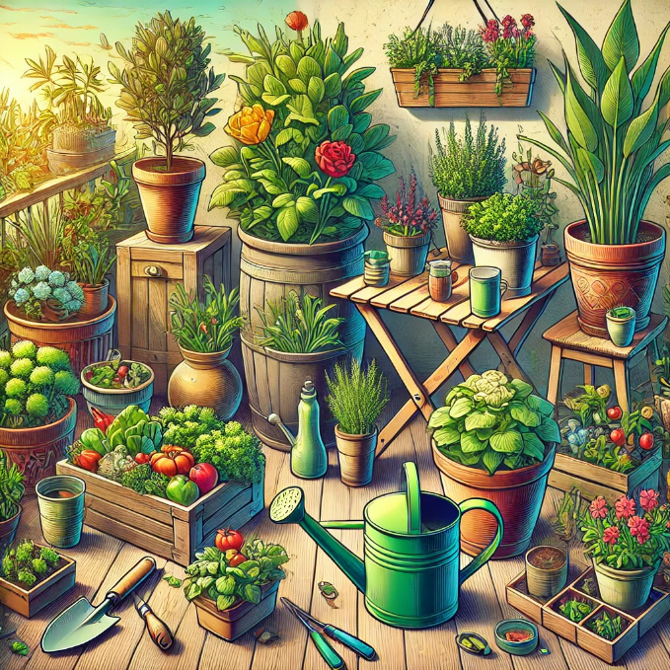

Chapter 1: Introduction to Container Gardening

Container gardening is a versatile and accessible way to grow a variety of plants, even in small or challenging spaces. Whether you are an urban dweller with limited outdoor space or a gardener looking for a controlled environment to cultivate specific plants, container gardening provides an ideal solution. In this chapter, we’ll dive into the core principles of container gardening, combining scientific insights with practical advice to help you create a successful, thriving garden.

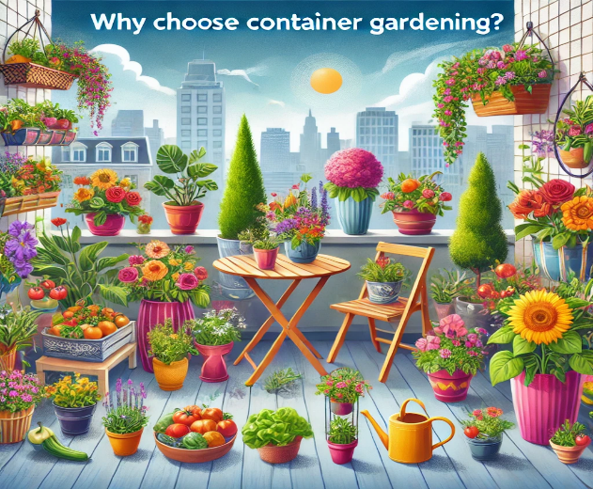

Why Choose Container Gardening?

Advantages of Container Gardening:

Space Efficiency: Perfect for balconies, patios, rooftops, and even windowsills.
Soil Control: You can customize soil mixes for specific plants, bypassing poor local soil conditions.
Mobility: Containers can be moved to optimize light exposure, temperature, or protection from inclement weather.
Design Flexibility: Containers can serve as both functional plant spaces and decorative features.

Scientific Insight: Plants in containers are in a self-contained environment, where they rely entirely on the potting mix for nutrients, water, and aeration. This can be a double-edged sword: on one hand, you have control over the environment; on the other, container plants are more sensitive to imbalances in water, nutrients, and temperature.

Key Takeaway: Container gardening offers flexibility and control, making it an excellent option for urban gardeners, those with limited space, and anyone looking to grow plants that might not thrive in their native soil.

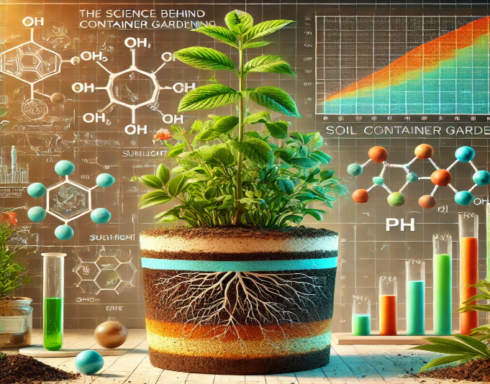

The Science Behind Container Gardening

Soil and Nutrient Management: In containers, plants depend entirely on the growing medium for nutrients. Soilless mixes are often preferred, as they provide essential aeration and moisture retention without compacting the way traditional garden soil might.

Scientific Insight: Most container gardeners use a mix made from components like peat moss, perlite, and vermiculite. These lightweight materials ensure proper drainage while retaining enough moisture for plant roots. However, due to limited soil volume, nutrients deplete quickly, so frequent fertilization is crucial.

Water Management: Containers dry out faster than in-ground gardens due to exposure on all sides. This rapid drying makes regular watering critical.

Scientific Insight: Water retention is influenced by container size, material, plant type, and ambient temperature. Containers made from porous materials like terracotta lose moisture more quickly, while plastic or glazed pots retain it longer. Adding materials like coconut coir can help maintain moisture levels.

Light and Photosynthesis: Light availability is a key determinant of plant health. Many urban container gardens face light limitations due to nearby buildings or shaded areas.

Scientific Insight: Different plants have varying light needs. Full-sun plants, like tomatoes, require at least six hours of direct sunlight, while shade-tolerant plants, like lettuce, thrive with less. It's essential to assess the sunlight your garden receives and choose plants accordingly.

Key Takeaway: Understanding the environmental needs of your plants—particularly in terms of soil, water, and light—helps create the conditions necessary for a thriving container garden.

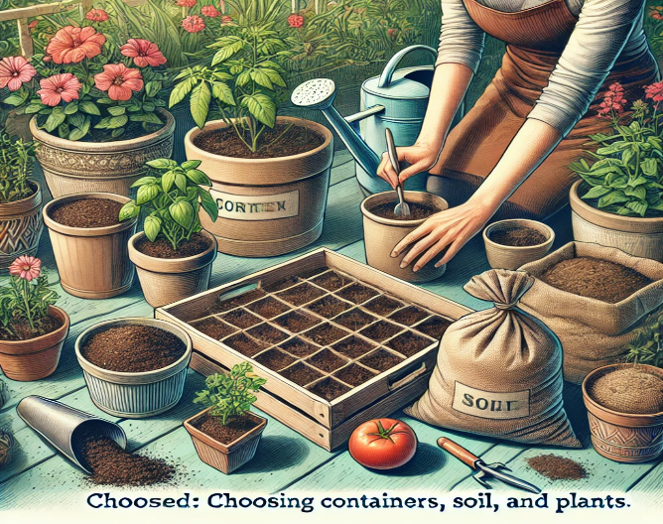

Getting Started: Choosing Containers, Soil, and Plants

Choosing the Right Containers: Selecting the right container is vital for plant health. Containers must provide enough space for roots to grow while offering adequate drainage.
Size: The container should be large enough to support the plant’s root system. A small container restricts growth, while an oversized container may hold too much moisture.

Material:
Plastic: Lightweight, moisture-retentive, but can overheat in direct sun.
Terracotta: Breathable, ideal for plants that prefer dry conditions, but dries out quickly.
Wood: Provides insulation, but may rot over time unless treated.
Fabric: Encourages air pruning, which helps roots develop more efficiently.

Practical Tip: If a container lacks drainage holes, drill them or create a drainage layer with gravel to prevent root rot.

Selecting the Right Soil: Potting mix should provide excellent drainage while retaining adequate moisture. Regular garden soil is too dense for container gardening and compacts easily.

Recommended Soil Mix:
1 part coconut coir or peat moss (for moisture retention)
1 part perlite or vermiculite (for drainage)
1 part compost (for nutrients)

Choosing the Best Plants for Containers: Some plants naturally do better in containers due to their root systems or growth habits.

Best Herbs: Basil, parsley, mint, and rosemary all thrive in containers.
Best Vegetables: Dwarf tomatoes, peppers, spinach, and lettuce are well-suited to small spaces.
Best Flowers: Marigolds, petunias, and geraniums add vibrant color to any container garden.

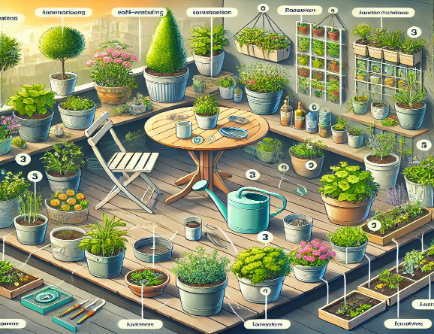

Practical Considerations for Container Gardening

Watering and Drainage: Proper watering is critical because containers dry out quickly. Deep watering encourages healthy root growth by ensuring that water penetrates to the bottom of the pot.
Practical Tip: Use mulch to reduce water evaporation, and water plants in the morning to minimize fungal growth and evaporation.

Fertilizing: Because container plants rely entirely on the nutrients in their potting mix, regular fertilization is essential. Use a balanced, slow-release fertilizer every 2–4 weeks during the growing season.

Temperature Control: Containers are more vulnerable to temperature fluctuations than in-ground plants. Move containers to shaded areas in the summer to prevent overheating, and bring them indoors in the winter to protect against frost.

Key Takeaway: Proper care, including regular watering, fertilizing, and temperature management, ensures that container plants thrive despite their limited growing space.

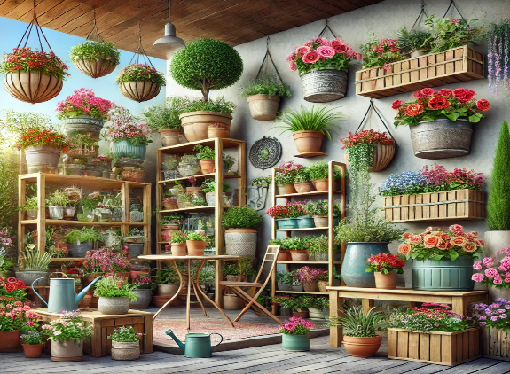

The Aesthetic and Functional Flexibility of Container Gardening

Container gardening allows for endless creativity. You can design aesthetically pleasing gardens with containers of various shapes, sizes, and colors.

Grouping Containers: Combine containers of different heights and textures for visual appeal.
Vertical Gardening: Maximize small spaces by using hanging baskets, trellises, or stackable planters.

Seasonal Displays: Rotate plants to ensure a year-round garden. For instance, plant bulbs in the spring, annuals in the summer, and evergreens in the winter.

Practical Tip: Follow the “thriller, filler, spiller” method for container design: choose a tall plant for height (thriller), surround it with medium plants for fullness (filler), and use trailing plants to cascade over the edge (spiller).

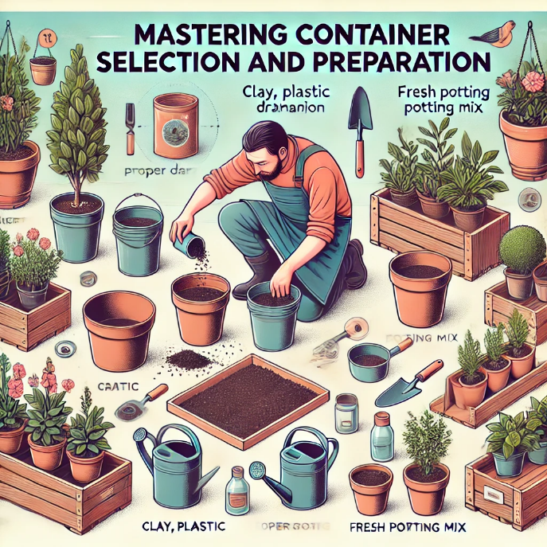

Chapter 2: Mastering Container Selection and Preparation

Container selection and proper preparation are foundational steps in creating a thriving container garden. The right container not only houses the plant but also affects its growth by influencing factors like water retention, aeration, and temperature. In this chapter, we will dive deep into the science of container selection and preparation, offering practical advice to help ensure plant health and optimize growth.

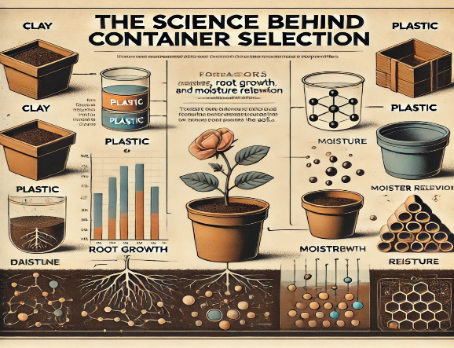

The Science Behind Container Selection

Why Containers Matter: The container serves as the root zone environment, and its material, size, and drainage capabilities directly affect plant growth. It regulates water availability, oxygen access, and nutrient uptake.

Scientific Insight: Roots need access to both water and oxygen. In a compacted or poorly aerated container, roots can suffocate, leading to stunted growth and root rot. Containers that allow sufficient drainage and airflow promote healthy root function, essential for nutrient absorption and overall plant vitality.

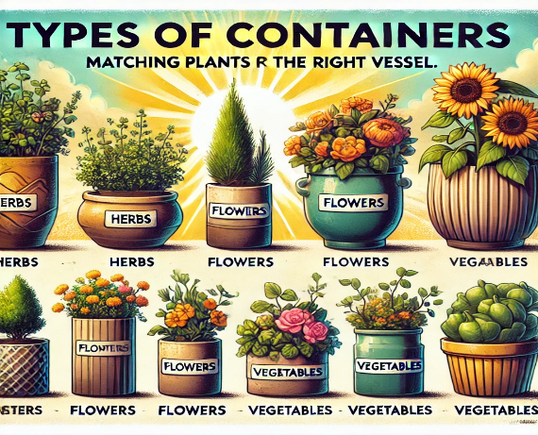
  - Types of Containers: Matching Plants to the Right Vessel

Selecting the correct container goes beyond aesthetics. The container material and size directly impact moisture retention, root development, and temperature regulation. Below are common container types and their benefits.

- Terracotta and Clay Pots:
  - Best for: Drought-tolerant plants such as succulents and Mediterranean herbs (e.g., thyme, rosemary).
  - Pros: The porous material allows air exchange and moisture evaporation, promoting healthy root aeration.
  - Cons: These containers dry out quickly and can crack in cold weather.

Practical Tip: For plants that require more moisture, line the inside of terracotta pots with plastic or water-retentive material to slow evaporation.

- Plastic Containers:
  - Best for: Leafy greens, vegetables (e.g., tomatoes, peppers), and annual flowers.
  - Pros: Lightweight, affordable, moisture-retentive, and available in various sizes.
  - Cons: Non-porous, which limits airflow and can lead to root rot if drainage is inadequate.

Scientific Insight: Plastic containers prevent moisture evaporation, making them ideal for plants that need consistent hydration. However, proper drainage is essential to avoid waterlogging.

- Ceramic Glazed Pots:
  - Best for: Ornamental plants and flowering varieties (e.g., begonias, geraniums).
  - Pros: Aesthetic appeal and excellent moisture retention.
  - Cons: Heavier than plastic or terracotta pots, and limited drainage without additional drainage holes.

Practical Tip: Use these pots for plants that enjoy constant moisture but be mindful of drainage. If no holes exist, consider drilling them or adding a drainage layer.

- Fabric Pots:
  - Best for: Root vegetables (e.g., carrots, potatoes), large vegetables (e.g., tomatoes), and herbs.
  - Pros: Fabric pots promote air pruning, which prevents root circling and allows more fibrous root development.
  - Cons: May dry out quickly, and the fabric can degrade over time.

Scientific Insight: Air pruning helps plants develop more fibrous root systems, resulting in better nutrient uptake and stronger plants.

- Wooden Containers:
  - Best for: Bushy plants, perennials, and small shrubs.
  - Pros: Insulates roots, stabilizes soil temperature, and offers a natural aesthetic.
  - Cons: Susceptible to rot over time unless treated with linings or preservatives.

Practical Tip: Line wooden containers with plastic to prevent rot, leaving space for drainage.

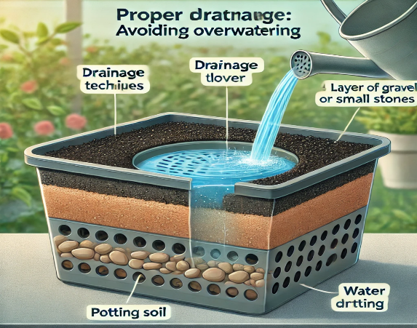

Proper Drainage Techniques: Avoiding Overwatering

Why Drainage is Critical: One of the leading causes of plant failure in container gardening is improper drainage. Without drainage, excess water saturates the soil, suffocating the roots and leading to root rot.

Effective Drainage Solutions:
- Drainage Holes: Ensure that all containers have multiple drainage holes at the base to allow excess water to escape.
- Layering Materials: Placing a layer of gravel, pebbles, or broken terracotta pieces at the bottom of the container can prevent soil compaction and improve drainage.

Scientific Insight: Poor drainage leads to anaerobic conditions in the soil, meaning the roots can't get oxygen, causing them to rot. Root rot, in turn, compromises the plant’s ability to absorb water and nutrients, leading to plant death.
Practical Tip: Avoid placing containers directly on solid surfaces like concrete. Elevate them on pot feet or stands to encourage airflow beneath the container, aiding in drainage.

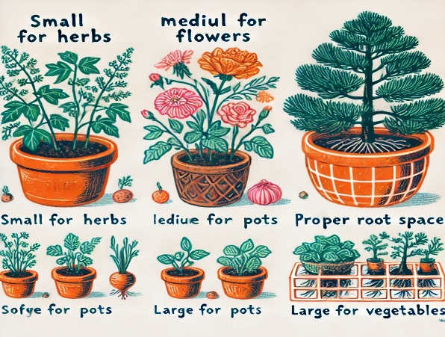

Choosing the Right Size and Material for Maximum Plant Growth

Container Size: The size of your container is just as crucial as the material. A container that is too small will restrict root growth, leading to poor plant development. A container that is too large can retain excess moisture, leading to root rot.

Size Guidelines for Common Plants:
- Herbs (Basil, Parsley, Cilantro): Minimum 6–8 inches deep.
- Vegetables (Tomatoes, Peppers): At least 12–18 inches deep and wide.
- Root Vegetables (Carrots, Beets): 10–12 inches deep.
- Fruit Trees (Dwarf Varieties): At least 18–24 inches deep and wide.

Material Considerations:
- Clay/Terracotta: Dries out quickly and cools down rapidly but provides good aeration.
- Plastic: Retains moisture but can cause root overheating in direct sun.
- Wood: Offers insulation but requires treatment to avoid rotting.
- Metal: Heats quickly and can damage roots in hot weather.

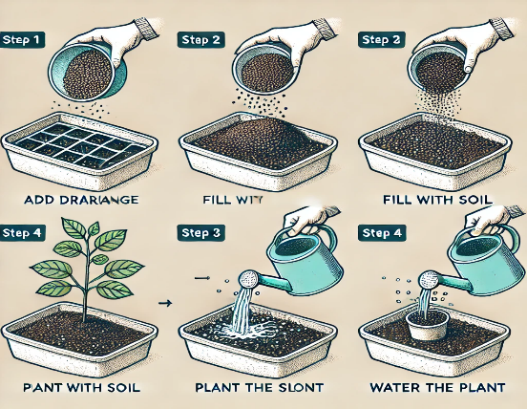

Preparing Containers for Planting: Step-by-Step

Once you’ve selected the appropriate container, proper preparation is key to creating a healthy environment for plant growth.

Steps for Preparing Containers:

- Clean the Container: Wash thoroughly with soap and water to remove debris, pathogens, and any chemicals from previous use.
- Check Drainage: Ensure that the drainage holes are open and sufficient. If necessary, drill more holes to allow water to escape freely.
- Add a Base Layer: Use a layer of gravel or broken pottery at the bottom of the container to improve drainage and prevent soil compaction.
- Pre-Moisten Potting Mix: Before filling the container, lightly moisten the potting mix. This helps ensure even water distribution and prevents dry spots.
- Fertilize and Amend: Mix in organic fertilizer or compost to give plants a nutrient-rich start. This is particularly important in containers where soil nutrients deplete quickly.

Scientific Insight: A well-prepared container ensures that water drains effectively while maintaining enough moisture for plant roots. The addition of a drainage layer prevents water from pooling at the bottom, which can lead to waterlogged roots.
Practical Tip: Always leave about 1–2 inches of space from the top of the container to the soil surface to prevent soil overflow during watering.

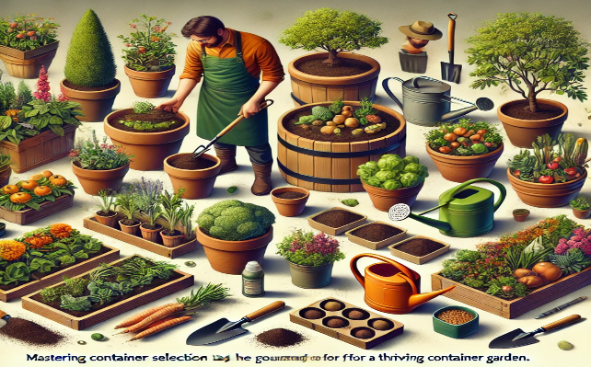

Conclusion: Mastering container selection and preparation

Mastering container selection and preparation lays the groundwork for a thriving container garden. By understanding how different materials, sizes, and drainage methods impact plant growth, you can create the optimal environment for your plants. A well-chosen container not only enhances plant health but also ensures that your garden remains aesthetically pleasing and functional.

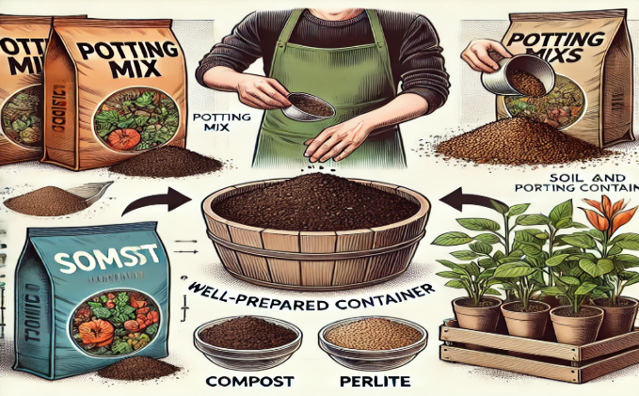

Chapter 3: Soil and Potting Mixes for Containers

The foundation of any thriving container garden lies in the quality of the soil or potting mix. Unlike in-ground gardening, where plants have access to a vast amount of soil and nutrients, container plants rely entirely on the confined growing medium. This chapter will explore the science of soil composition, how to create custom potting mixes, the importance of soil pH and nutrient balance, and the appropriate soil depth for various plants.

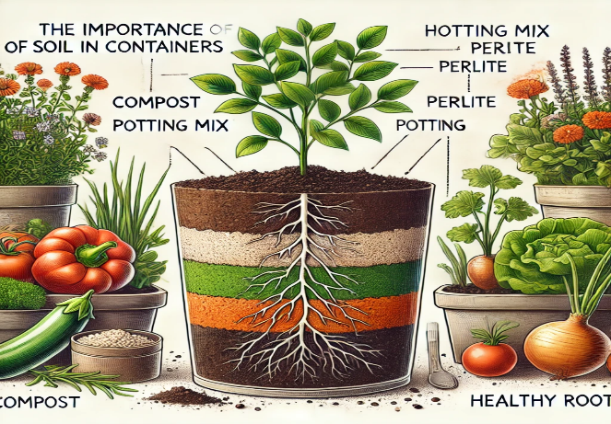
3.1 The Importance of Soil in Containers

Why Soil Matters: In a container garden, soil serves four primary functions: it provides structure for the plant's roots, holds moisture and nutrients, supports aeration for root respiration, and acts as a reservoir for microbial activity. These factors work together to promote healthy plant growth, but achieving the right balance in a limited space can be challenging.

Scientific Insight: The confined nature of container gardening means that soil compaction, water retention, and nutrient depletion can occur quickly. Garden soil is typically too dense for container use, as it can become compacted, limiting airflow to the roots and leading to poor drainage.

Key Takeaway: Using the right potting mix is essential for maintaining the balance between moisture retention, aeration, and nutrient availability. A properly balanced mix ensures that container plants thrive even in confined spaces.

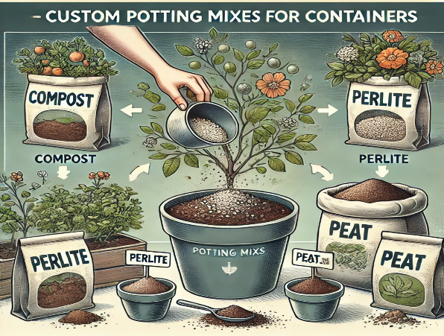

3.2 Custom Potting Mixes for Containers

Building the Perfect Potting Mix: While pre-packaged potting mixes are readily available, creating a custom blend allows you to tailor the mix to the specific needs of your plants. The best potting mix is light, well-draining, and nutrient-rich. It typically consists of three main components:

- Base Materials (for structure and drainage):
  - Coconut Coir: A sustainable, eco-friendly material that retains water while offering excellent drainage.
  - Peat Moss: Effective for moisture retention, though it can become compacted over time. Mix with other materials for improved aeration.
  - Composted Bark: Adds structure and improves drainage, especially for larger plants.

- Aeration Materials:
  - Perlite: A lightweight volcanic rock that increases soil porosity, ensuring that roots receive adequate oxygen.
  - Vermiculite: Holds moisture and nutrients while also promoting aeration, ideal for moisture-loving plants.
  - Pumice: Heavier than perlite but offers long-lasting aeration, particularly beneficial for long-term container gardening.

- Nutrient Additives:
  - Compost: Rich in organic matter, compost adds essential nutrients and enhances soil structure.
  - Worm Castings: A powerful organic fertilizer that boosts microbial activity and improves plant health.
  - Slow-Release Fertilizer: Provides steady, long-term nutrient availability, ensuring plants are well-fed over time.

Custom Potting Mix Recipe:

- 40% Coconut Coir/Peat Moss (for moisture retention and structure)
- 30% Compost (for nutrients and organic matter)
- 20% Perlite/Vermiculite (for aeration and drainage)
- 10% Worm Castings (for nutrient boost)

Scientific Insight: The key to a healthy potting mix is finding the right balance between moisture retention and aeration. A mix that holds too much water can suffocate roots, while one that drains too quickly may leave plants dehydrated.
Practical Tip: For fast-draining soils (like those for succulents), increase the proportion of perlite or pumice. For moisture-loving plants (like ferns), add more coconut coir or peat moss to retain water.

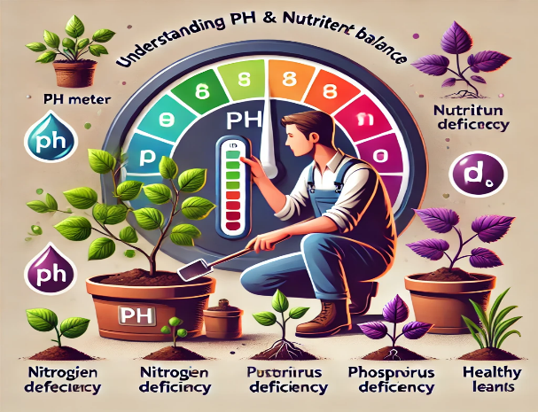

3.3 Understanding Soil pH and Nutrient Balance

Soil pH: Soil pH measures the acidity or alkalinity of the soil and plays a crucial role in nutrient availability. Different plants have specific pH preferences, and maintaining the proper pH is essential for nutrient uptake.

- Ideal pH Range for Most Container Plants: 6.0 to 7.0 (slightly acidic to neutral).

Scientific Insight: Soil pH affects the solubility of essential nutrients like nitrogen, phosphorus, and potassium. Outside the optimal pH range, these nutrients become less available, even if they are present in the soil. Additionally, a low pH (acidic soil) can increase the presence of toxic elements like aluminum, which can damage roots.

Adjusting pH in Containers:
- To Lower pH (make soil more acidic): Add sulfur, peat moss, or coffee grounds.
- To Raise pH (make soil more alkaline): Use lime or wood ash.

Practical Tip: Test your soil’s pH using a simple test kit or digital meter. Adjust slowly, as drastic changes can shock your plants.

Nutrient Availability: Plants require macronutrients (nitrogen, phosphorus, potassium) and micronutrients (iron, magnesium, zinc) to thrive. In container gardening, nutrient levels deplete quickly due to frequent watering, so regular fertilization is necessary to replenish them.

- Macronutrients:
  - Nitrogen (N): Promotes leafy growth.
  - Phosphorus (P): Encourages root development and flowering.
  - Potassium (K): Enhances overall plant health and disease resistance.
- Micronutrients:
  - Iron (Fe): Supports chlorophyll production, essential for photosynthesis.
  - Magnesium (Mg): Key in chlorophyll structure and plant metabolism.
  - Zinc (Zn): Aids in enzyme function and growth regulation.

Here is the table showing optimal pH levels for common container plants and nutrient deficiency symptoms to watch for:

Plant | Optimal pH Range
  Nutrient Deficiency Symptoms
Tomatoes
  6.0 - 6.8
  Yellowing leaves (Nitrogen deficiency)
Basil
  6.0 - 7.5
  Pale leaves (Iron deficiency)
Petunias
  5.5 - 6.5
  Yellowing leaves (Nitrogen deficiency)
Roses
  6.0 - 6.5
  Yellowing between leaf veins (Magnesium deficiency)
Mint
  6.0 - 7.5
  Yellowing leaves (Nitrogen deficiency)
Spinach
  6.0 - 7.5
  Yellow leaves with green veins (Iron deficiency)
Lettuce
  6.0 - 7.0
  Yellowing leaves (Nitrogen deficiency)
Peppers
  6.0 - 7.0
  Yellowing leaves (Nitrogen deficiency)
Cucumbers
  5.5 - 7.0
  Stunted growth, purpling leaves (Phosphorus deficiency)
Strawberries |  | Yellowing between leaf veins (Magnesium deficiency)
  5.5 - 6.5

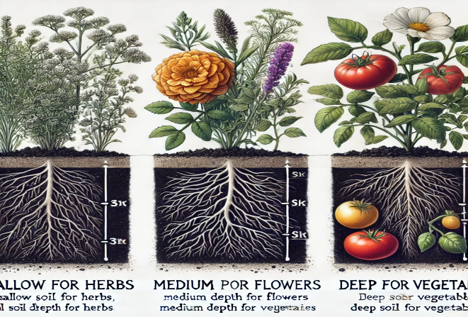
3.4 Proper Soil Depth for Different Plants

Why Depth Matters: The depth of the soil in your containers influences root growth, water retention, and nutrient availability. Shallow containers can limit root expansion, while excessively deep containers may lead to poor drainage.

Soil Depth Guidelines for Common Container Plants:
- Leafy Greens (Lettuce, Spinach): 6–8 inches deep.
- Herbs (Basil, Thyme): 8–10 inches deep.
- Root Vegetables (Carrots, Radishes): 10–12 inches deep.
- Tomatoes, Peppers, Eggplants: 12–18 inches deep.
- Dwarf Fruit Trees: 18–24 inches deep.

Scientific Insight: Roots expand laterally as well as vertically, so it's important to provide adequate space in both dimensions. Plants with deep root systems, such as tomatoes, need containers that offer both depth and width to allow for proper water absorption and root expansion.
Practical Tip: Ensure your container provides not only the required soil depth but also enough width to allow lateral root development. This is especially crucial for larger plants like dwarf fruit trees or large vegetables.

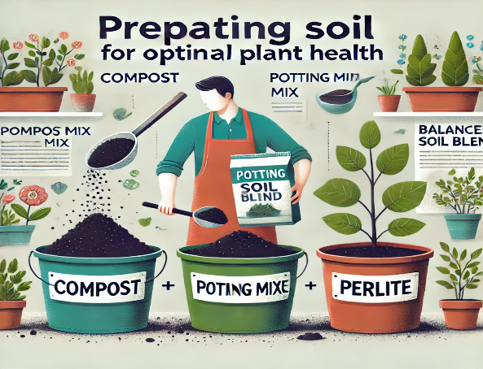
3.5 Preparing Soil for Optimal Plant Health

Steps for Preparing Soil in Containers:

- Moisten the Potting Mix: Before planting, lightly water the potting mix to ensure even moisture distribution. This prevents dry pockets from forming.
- Fill the Container: Add the moistened potting mix to the container, leaving about 1–2 inches of space at the top to prevent overflow during watering.
- Tamp Down Gently: Lightly press the soil to remove large air pockets but avoid compacting it too much, as this can restrict root growth.
- Add Fertilizers or Amendments: Incorporate slow-release fertilizers or organic compost into the soil mix to provide a nutrient boost for the plants.
- Monitor Watering: Container soil dries out faster than garden soil, so it's important to monitor moisture levels regularly. Mulching the soil surface can help retain moisture.

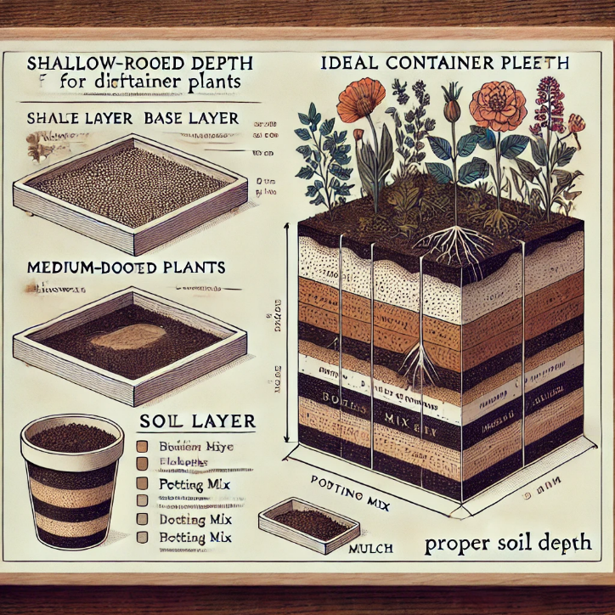

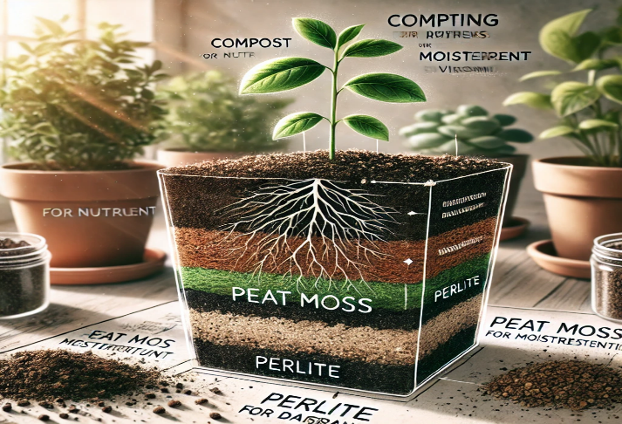
Conclusion: Creating the ideal soil environment

Creating the ideal soil environment in a container is crucial to plant health and success. A well-balanced potting mix, coupled with proper pH and nutrient management, provides plants with the structure and resources they need to thrive in a confined space. Understanding the specific requirements of your plants allows you to tailor the soil to their needs, ensuring optimal growth and productivity.

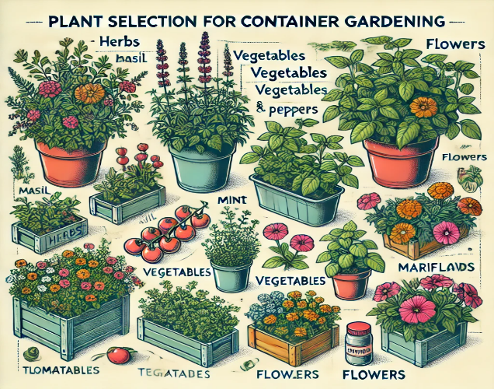

Chapter 4: Plant Selection for Container Gardening

Choosing the right plants for container gardening is crucial for success. In containers, plants face unique challenges such as limited root space, fluctuating moisture levels, and restricted nutrient access. In this chapter, we will explore how to select the best plants for container gardening, focusing on vegetables, herbs, flowers, and companion planting. We'll also cover how to choose plants based on climate, light exposure, and plant compatibility to create a thriving, beautiful container garden.

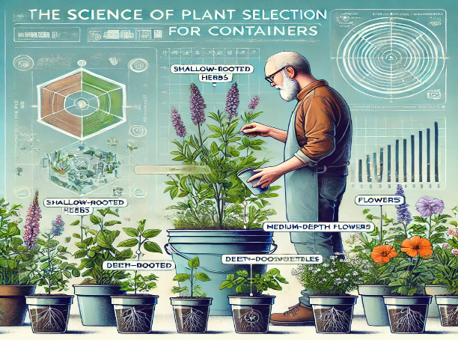

The Science of Plant Selection for Containers

Why Plant Selection Matters: Unlike in-ground gardens, plants grown in containers must adapt to a more controlled and often restricted environment. The size of the container, the available nutrients, and the watering schedule all limit plant growth. Selecting plants that are well-suited for these conditions ensures healthy growth and minimizes competition between species.

Scientific Insight: Plants with shallow or fibrous root systems tend to do better in containers since they don’t need extensive soil depth to thrive. However, plants with deep root systems, like tomatoes, can still thrive in containers if provided with enough space. Understanding the root structure and water needs of each plant will help ensure they grow well in confined conditions.

Key Takeaway: Choosing plants based on their root system, growth habits, and environmental needs is essential to a successful container garden.

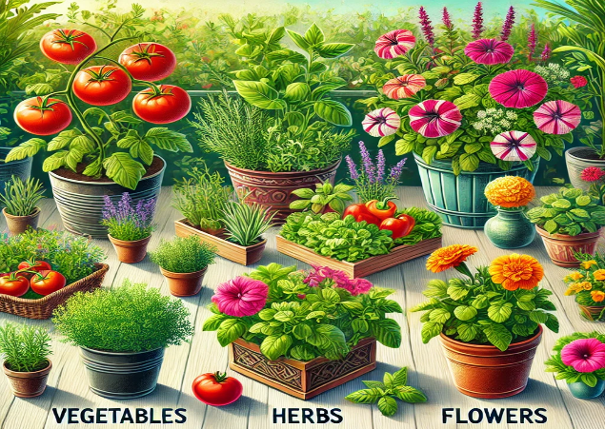

Best Plants for Containers: Vegetables, Herbs, and Flowers

Vegetables for Container Gardening

Vegetable gardening in containers allows you to grow fresh produce even in small spaces. Some vegetables adapt particularly well to the confined conditions of containers.

Best Vegetables for Containers:
- Tomatoes (Solanum Lycopersicon): Compact determinate varieties like ‘Patio Princess’ and ‘Bush Early Girl’ are ideal for container growing. They need large pots (12–18 inches deep) and consistent watering.
- Peppers (Capsicum annuum): Both hot and sweet varieties, such as ‘Jalapeño’ and ‘Mini Bell,’ thrive in containers with at least 12 inches of soil depth.
- Leafy Greens (Lactuca sativa, Spinacia oleracea): Lettuce, spinach, and kale grow well in shallow containers (6–8 inches deep) and prefer cooler temperatures with partial shade.
- Radishes (Raphanus sativus): These fast-growing, shallow-rooted vegetables need only 6 inches of soil depth and are perfect for small containers.
- Carrots (Daucus carota): Short varieties like ‘Thumbelina’ or ‘Paris Market’ need at least 10–12 inches of soil depth for proper root development.

Practical Tip: Use high-quality potting soil with excellent drainage for vegetables. Most vegetables grown in containers need at least 6–8 hours of sunlight per day and regular fertilization to produce high yields.

Herbs for Container Gardening

Herbs are a perfect match for container gardens due to their compact size, ease of care, and continuous harvest potential. Some herbs thrive in confined spaces and can even be combined in the same container for a mini herb garden.

Best Herbs for Containers:
- Basil (Ocimum basilicum): Thrives in full sun and needs at least 6–8 inches of soil depth. Basil is an excellent companion plant for tomatoes and peppers.
- Mint (Mentha spp.): Best grown in its own container due to its aggressive spread. It prefers partial shade and consistently moist conditions.
- Thyme (Thymus vulgaris): A drought-tolerant herb that does well in shallow pots with full sun exposure.
- Cilantro (Coriandrum sativum): Prefers cool weather and partial shade, needing at least 8 inches of soil depth.
- Rosemary (Salvia rosmarinus): A woody herb that thrives in warm, sunny conditions and well-drained soil (8–12 inches deep).

Practical Tip: Group herbs with similar water and light needs in the same container. For example, Mediterranean herbs like rosemary, thyme, and oregano prefer drier conditions, while basil and cilantro need more moisture.

Flowers for Container Gardening

Flowers bring beauty and color to any container garden, and many flowering plants adapt well to container environments.

Best Flowers for Containers:
- Petunias (Petunia spp.): Versatile and available in many colors, petunias require full sun and at least 8–10 inches of soil depth.
- Geraniums (Pelargonium spp.): Drought-tolerant and easy to grow, they need well-drained soil and full sun.
- Begonias (Begonia spp.): Ideal for shaded areas, they thrive in moist, well-draining soil with at least 8 inches of depth.
- Marigolds (Tagetes spp.): These sun-loving flowers also help repel pests like aphids. They need 6–8 hours of sunlight and at least 8 inches of soil depth.
- Impatiens (Impatiens walleriana): Excellent for shady areas, they are perfect for hanging baskets or containers in low-light spots.

Practical Tip: Mix and match flowers with different growth habits, colors, and blooming times to create a long-lasting and visually interesting display.

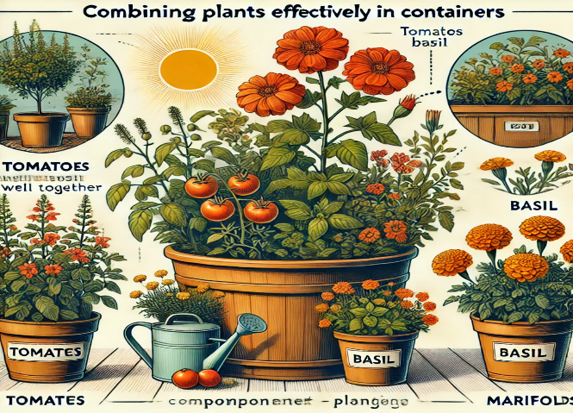

Combining Plants Effectively in Containers

Why Combine Plants?: Combining plants in the same container is an efficient way to maximize space, create visually appealing displays, and encourage beneficial plant partnerships. However, successful combinations require plants that share similar water, light, and nutrient needs.

The Thriller, Filler, Spiller Method: A classic approach to container design, this method uses three plant types to create visually balanced containers:
- Thrillers: Tall, focal plants that add height and structure (e.g., ornamental grasses, geraniums).
- Fillers: Medium-height plants that provide volume (e.g., petunias, marigolds, basil).
- Spillers: Trailing plants that cascade over the edges of the container (e.g., ivy, trailing thyme, sweet potato vine).

Scientific Insight: Combining plants with complementary root systems can help prevent overcrowding. For example, deep-rooted plants like tomatoes can be paired with shallow-rooted herbs like thyme to make efficient use of the soil depth without competing for space.

Companion Planting in Containers: Certain plant combinations can deter pests, improve pollination, or enhance growth. Here are some beneficial pairings for container gardens:
- Tomatoes and Basil: Basil repels harmful insects and may enhance the flavor of tomatoes.
- Peppers and Marigolds: Marigolds deter nematodes and aphids that can harm pepper plants.
- Cucumbers and Dill: Dill attracts beneficial insects like ladybugs, which help control cucumber pests.

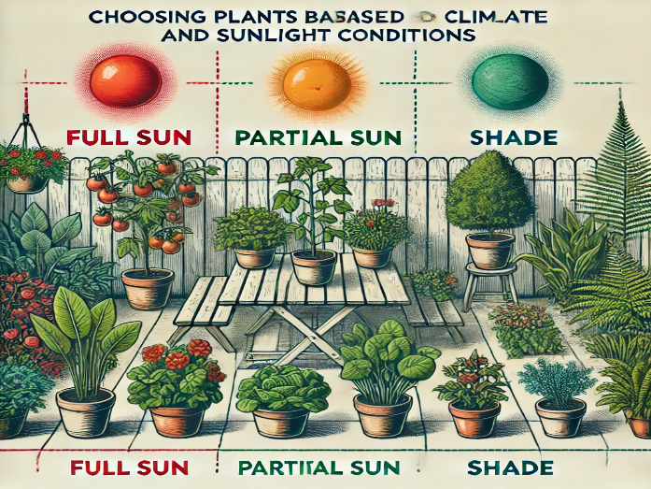

Choosing Plants Based on Climate and Sunlight Conditions

Why Climate and Sunlight Matter: Different plants have specific temperature, humidity, and sunlight requirements. Selecting the right plants for your climate and container location ensures they thrive and remain healthy.

Choosing Plants Based on Sunlight: Understanding the amount of sunlight your container garden receives is key to choosing the right plants.

- Full Sun (6–8 hours of direct sunlight): Ideal for tomatoes, peppers, basil, petunias, and marigolds.
- Partial Sun/Partial Shade (4–6 hours of sunlight): Great for leafy greens, cilantro, mint, impatiens, and begonias.
- Full Shade (Less than 4 hours of sunlight): Suitable for plants like ferns, hostas, and coleus.

Practical Tip: Monitor how much sunlight your containers receive throughout the day and choose plants accordingly. Adjust the placement of containers based on seasonal light changes.

Choosing Plants Based on Climate: Your local climate affects which plants will thrive. Use the USDA Hardiness Zone Map to determine your zone and select plants accordingly.

- Warm Climates (Zones 8–11): Heat-tolerant plants like tomatoes, peppers, basil, and succulents will thrive.
- Cool Climates (Zones 3–7): Opt for cool-season crops like spinach, kale, and root vegetables.
- Tropical Climates: Choose humidity-loving plants like ferns and tropical herbs such as lemongrass.

  Climate Zone
  Sunlight Condition
  Recommended Container Plants
Tropical | Full Sun (6+ hours)
  Tomatoes, Peppers, Basil, Eggplants
 | Partial Sun (4-6 hours)
  Mint, Parsley, Oregano
 | Shade (Less than 4 hours)
  Fern, Snake Plant, Peace Lily
Mediterranean | Full Sun (6+ hours)
  Lavender, Rosemary, Citrus Trees
 | Partial Sun (4-6 hours)
  Geraniums, Marjoram, Thyme
 | Shade (Less than 4 hours)
  Hostas, Ivy, Caladium
Temperate | Full Sun (6+ hours)
  Petunias, Lettuce, Zucchini
 | Partial Sun (4-6 hours)
  Spinach, Swiss Chard, Begonia
 | Shade (Less than 4 hours)
  Ferns, Impatiens, Coleus
Cool/Cold | Full Sun (6+ hours) | Kale, Chard, Pansies
 | Partial Sun (4-6 hours) | Dwarf Conifers, Primrose, Violas
 | Shade (Less than 4 hours) | Ferns, Hellebore, Heuchera

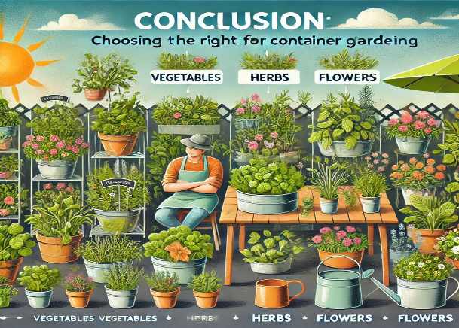

Conclusion: Choosing the right plants for container gardening

Choosing the right plants for container gardening is essential for creating a successful, thriving garden. By selecting plants based on their root structure, sunlight requirements, and climate compatibility, you can maximize your container garden’s productivity and beauty. Thoughtful combinations of vegetables, herbs, and flowers not only save space but also enhance your garden’s aesthetic appeal.

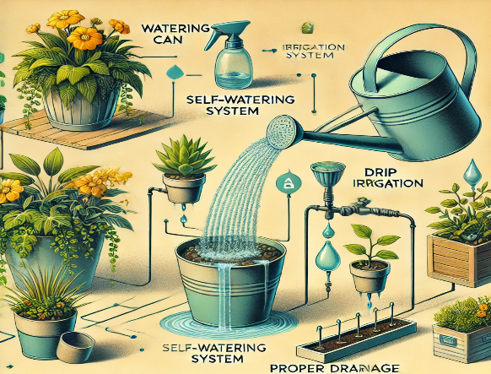

Chapter 5: Watering and Irrigation Techniques for Container Gardens

Watering is one of the most critical aspects of container gardening. Because containers are self-contained environments, they dry out more quickly than traditional in-ground gardens. In this chapter, we’ll explore the science of watering and irrigation in containers, covering proper watering techniques, self-watering systems, and how to identify and correct watering issues like overwatering or underwatering.

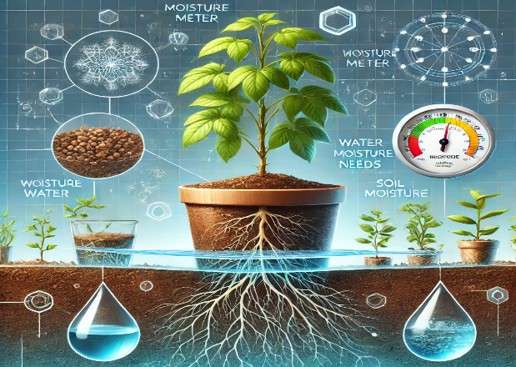

The Science of Watering: Understanding Plant Water Needs

Why Proper Watering is Essential: Water is a fundamental element for plant survival and growth, playing a crucial role in nutrient transportation, temperature regulation, and photosynthesis. In container gardening, managing water efficiently is even more important because the restricted space can lead to quick water evaporation or waterlogging.

Scientific Insight: Plants lose water through transpiration, where water evaporates from the leaves, creating a pressure gradient that pulls water from the soil. In containers, the limited root space and fast-drying nature of many potting mixes mean that water stress—either too much or too little—occurs faster than in traditional garden soil.

Key Takeaway: Proper watering is crucial in containers because of the rapid evaporation and limited soil volume. The goal is to maintain consistent moisture levels without over-saturating the soil.

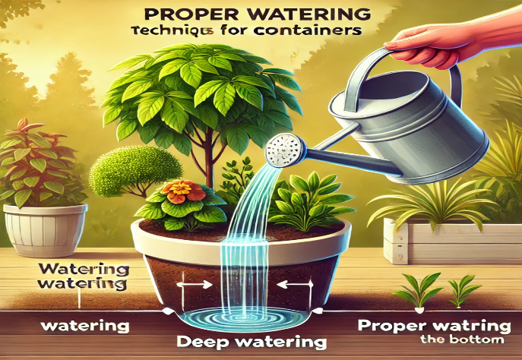

Proper Watering Techniques for Containers

Timing and Frequency of Watering: Container plants require a more controlled approach to watering compared to in-ground plants. Overwatering and underwatering are common issues, and both can lead to plant stress or death.

- Morning Watering: The best time to water is early in the morning. This allows plants to absorb moisture before the heat of the day and reduces the risk of fungal infections that thrive in damp, cool conditions at night.
- Frequency: The frequency of watering depends on several factors, including the type of plant, the size of the container, and the weather. In hot, dry climates, daily watering may be necessary, while in cooler climates, watering every few days may suffice.
- Deep Watering: Watering deeply ensures that the entire root system is hydrated. Water the container until water begins to drain from the bottom, which encourages deep root growth and helps plants access moisture more effectively.

Scientific Insight: In containers, shallow watering leads to shallow root systems, which makes plants more vulnerable to drought stress. Deep watering encourages roots to grow deeper, providing better access to water during dry periods.
Practical Tip: To check if a plant needs water, insert your finger about an inch into the soil. If the soil feels dry at that depth, it’s time to water. For larger containers, using a moisture meter can provide more accurate readings.

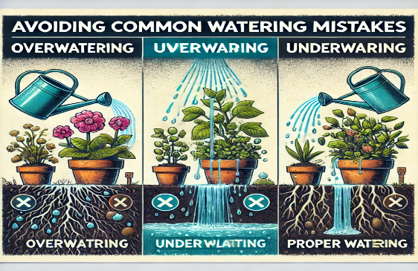

Avoiding Common Watering Mistakes

Overwatering and Underwatering: Both overwatering and underwatering can cause significant damage to plants, but the symptoms of each are different.

- Overwatering Symptoms: Wilting despite wet soil, yellowing leaves, root rot, and mold growth on the soil surface.
- Underwatering Symptoms: Dry, curling leaves, soil pulling away from the container edges, slow growth, and the plant appearing generally wilted.

Scientific Insight: Overwatering fills the air pockets in the soil with water, cutting off oxygen to the roots. Without oxygen, roots cannot perform respiration, leading to root rot, a condition in which roots decay and can no longer absorb water or nutrients.
Practical Tip: When watering, ensure that water drains from the bottom of the container. If water drains immediately, the soil may be too dry and compacted. In this case, water slowly to allow the soil to rehydrate evenly.

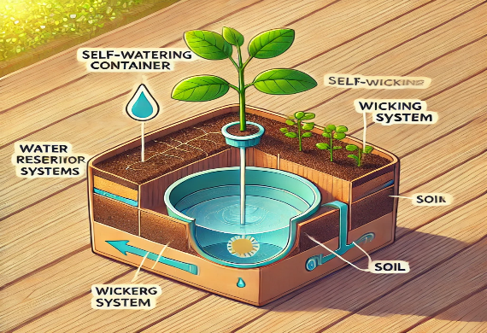

Self-Watering Container Systems

What Are Self-Watering Containers?: Self-watering containers simplify the watering process by maintaining consistent moisture levels in the soil. These containers feature a water reservoir at the base, which supplies moisture to the soil through a wicking mechanism, allowing plants to absorb water as needed.

How Self-Watering Containers Work:
- Water Reservoir: A reservoir at the bottom of the container holds water.
- Wicking System: A wick or column of soil draws water upward from the reservoir into the root zone as the soil dries out.
- Overflow Drainage: An overflow hole prevents excess water from accumulating, avoiding waterlogging.

Scientific Insight: Self-watering containers use capillary action to provide consistent moisture. This is particularly beneficial for plants like tomatoes, which require a steady supply of water to avoid issues like blossom end rot.

Benefits of Self-Watering Containers:
- Reduced Maintenance: These containers reduce the need for frequent watering, making them ideal for busy gardeners or those in hot climates.
- Water Efficiency: The water reservoir minimizes evaporation and ensures plants can access moisture as needed.
- Prevention of Water Stress: Self-watering systems help prevent plants from drying out or becoming waterlogged, providing a more stable growing environment.

Practical Tip: Self-watering containers are perfect for moisture-loving plants like vegetables and herbs but may not be suitable for drought-tolerant plants like succulents, which prefer drier conditions.

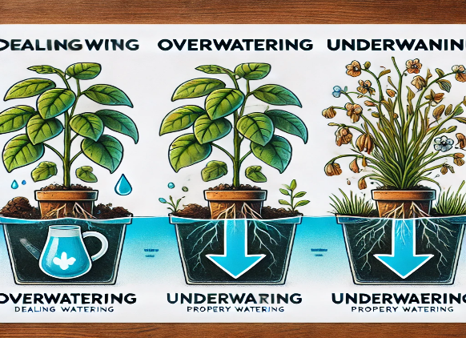

Dealing with Overwatering and Underwatering Issues

How to Fix Overwatering: Overwatering often leads to root rot, where roots decay due to a lack of oxygen. Here’s how to correct overwatering:

- Stop Watering Temporarily: Allow the soil to dry out before watering again. In extreme cases, remove the plant from its container and shake off excess soil.
- Improve Drainage: Ensure drainage holes are clear and add gravel or stones to the bottom of the container to enhance drainage.
- Trim Rotted Roots: Remove any black or mushy roots with sterilized scissors. Healthy roots are white and firm.
- Repot in Fresh Soil: If root rot has occurred, repot the plant in fresh, well-draining soil, and water sparingly until new growth appears.

Practical Tip: Always check that your containers have adequate drainage holes. If water pools at the bottom, roots can suffocate and develop rot, even if the plant appears healthy above ground.

How to Fix Underwatering: Underwatering is usually easier to fix than overwatering, but it still stresses plants. The key is to rehydrate the soil and adjust the watering schedule.

- Rehydrate the Soil: If the soil is extremely dry, it may resist water. Submerge the container in water for 10–20 minutes to allow the soil to absorb moisture from the bottom up.
- Add Mulch: Mulch helps retain moisture in the soil and reduces the need for frequent watering.
- Adjust Watering Schedule: Increase the frequency of watering, especially during hot weather, to maintain consistent soil moisture levels.

Practical Tip: In hot, sunny locations, place containers on saucers filled with water to prevent rapid soil drying. Ensure that the container is slightly elevated to prevent roots from sitting in stagnant water.

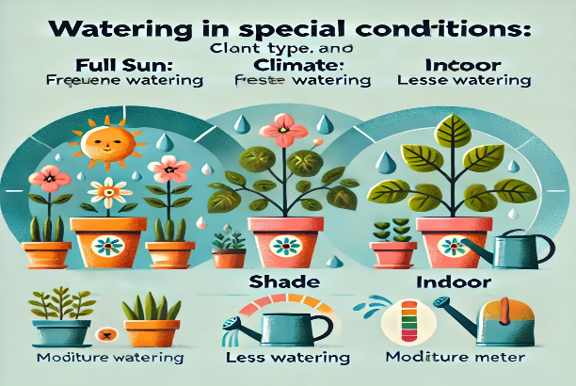

Watering in Special Conditions: Climate, Plant Type, and Location

Hot Climates and Watering: In hot climates, containers dry out quickly due to increased evaporation. Here are some tips to keep your plants hydrated:

- Water Early or Late: Watering in the morning or evening minimizes evaporation and gives plants time to absorb moisture before the heat sets in.
- Use Mulch: A layer of mulch insulates the soil, reducing water loss from evaporation.
- Provide Shade: Move containers to a shaded area during the hottest parts of the day to reduce water stress.

Drought-Tolerant Plants: Succulents and other drought-tolerant plants prefer drier conditions and should not be overwatered. Here’s how to care for these types of plants:

- Water Sparingly: Allow the soil to dry completely between waterings. Water deeply but infrequently.
- Use Well-Draining Soil: Drought-tolerant plants need a fast-draining soil mix with a high proportion of perlite, pumice, or sand to avoid moisture retention.

Watering Indoor Plants: Indoor container plants face different challenges than outdoor plants, primarily because they experience less evaporation.

- Check Humidity: Indoor environments can be dry, especially in air-conditioned or heated spaces. Mist plants or use a humidifier to maintain humidity levels.
- Avoid Overwatering: Since indoor plants experience less evaporation, be mindful of overwatering. Check soil moisture regularly and water only when needed.

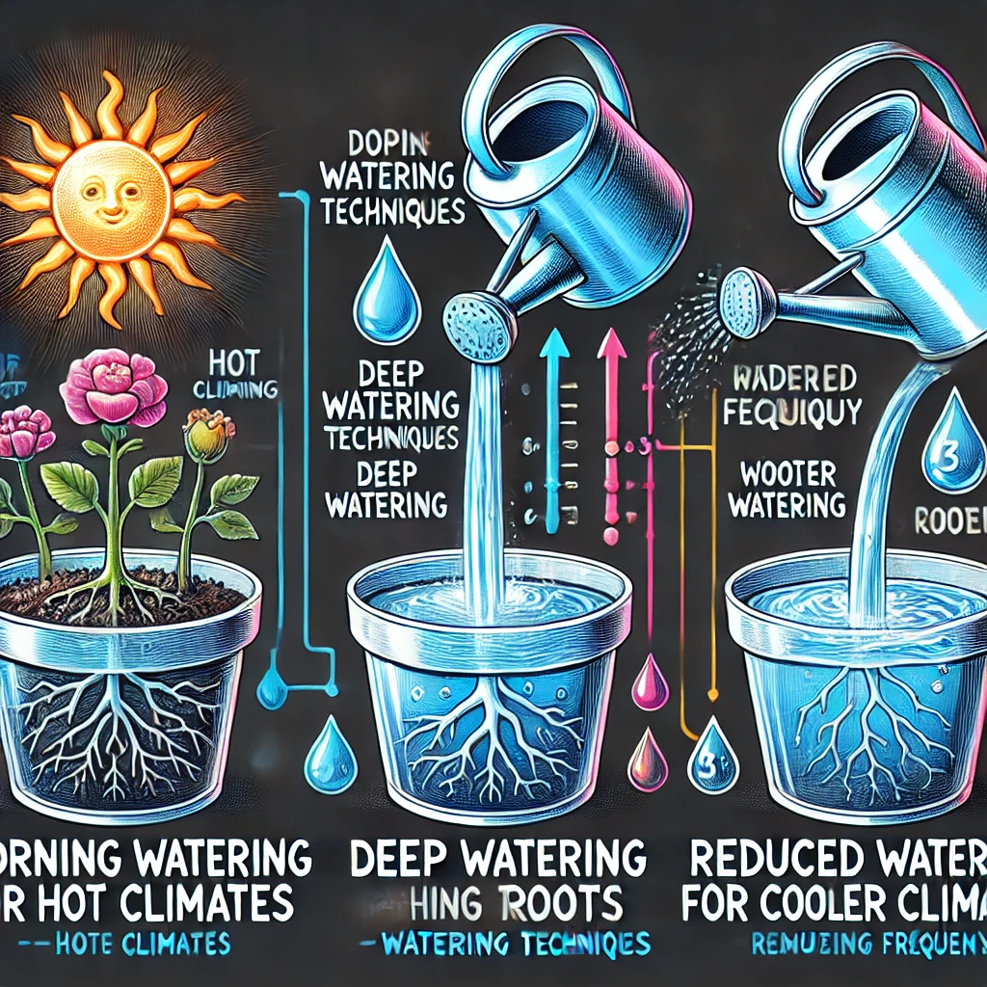

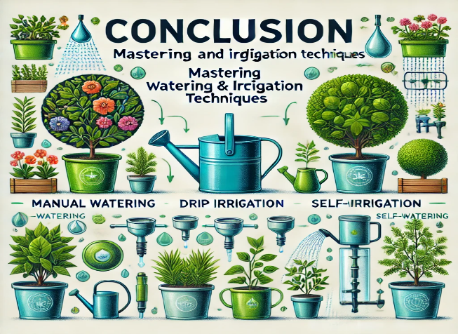
Conclusion: Mastering watering and irrigation techniques

Mastering watering and irrigation techniques is essential for maintaining healthy container plants. Whether you're using traditional watering methods or self-watering containers, the key is to understand your plants' specific water needs and provide consistent hydration without overwatering. By monitoring the soil, adjusting watering schedules for climate, and using effective irrigation systems, you can ensure your container garden thrives.

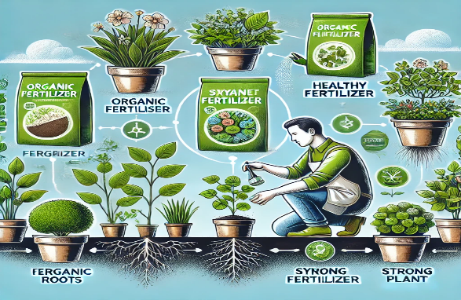

Chapter 6: Fertilizing and Plant Nutrition for Container Gardens

Fertilizing container plants is crucial to their health and productivity. Because the soil in containers is limited and nutrients are depleted quickly through watering and plant uptake, regular replenishment is essential. In this chapter, we will explore the science of plant nutrition, different types of fertilizers, how to create fertilization schedules, and the pros and cons of organic vs. synthetic fertilizers.

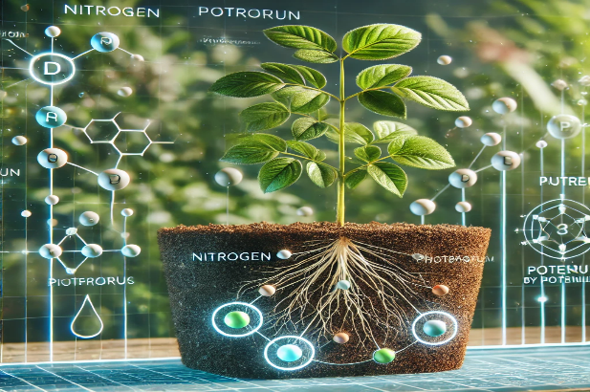

The Science of Plant Nutrition in Containers

Why Fertilizing is Essential: In traditional in-ground gardening, plants have access to a large volume of soil where they can continually draw nutrients. However, in containers, the soil volume is limited, and plants quickly exhaust the available nutrients. Without regular fertilization, container plants can become nutrient deficient, leading to stunted growth, yellowing leaves, and poor flowering or fruiting.

Scientific Insight: Plants require 17 essential nutrients for growth, which are divided into three categories: macronutrients, secondary nutrients, and micronutrients.

- Macronutrients: Nitrogen (N), phosphorus (P), and potassium (K) are needed in large amounts. Nitrogen promotes leafy growth, phosphorus aids in root and flower development, and potassium improves overall plant health and disease resistance.
- Secondary Nutrients: Calcium (Ca), magnesium (Mg), and sulfur (S) are also crucial for cellular structure, photosynthesis, and protein synthesis.
- Micronutrients: Iron (Fe), zinc (Zn), manganese (Mn), and copper (Cu) are needed in smaller quantities but are vital for enzyme function and chlorophyll production.

Key Takeaway: Because container plants deplete nutrients faster than in-ground plants, regular fertilization is necessary to ensure healthy growth and productivity.

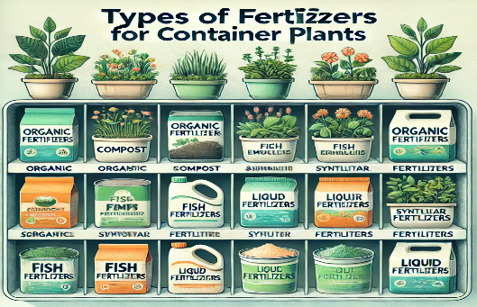

Types of Fertilizers for Container Plants

Fertilizers come in two main categories: organic and synthetic. Both have their benefits and drawbacks, and choosing the right one depends on your gardening goals, preferences, and the specific needs of your plants.

Organic Fertilizers

Organic fertilizers come from natural sources such as compost, manure, and plant residues. They improve soil structure, encourage microbial activity, and release nutrients slowly over time.

- Compost: Provides a balanced source of nutrients while improving soil texture.
- Worm Castings: Rich in nutrients and beneficial microbes, worm castings promote plant growth and soil health.
- Bone Meal: High in phosphorus, bone meal encourages strong root systems and flowering.
- Fish Emulsion: A nitrogen-rich liquid fertilizer that boosts leafy growth, particularly useful for vegetables.
- Seaweed Extract: Contains micronutrients and growth hormones that enhance plant health and resilience.

Scientific Insight: Organic fertilizers rely on soil microorganisms to break down organic matter and release nutrients slowly. While this reduces the risk of over-fertilization, it may not meet the immediate nutrient demands of fast-growing plants.
Practical Tip: Incorporate organic fertilizers like compost or worm castings into your potting mix at planting time, and continue to top-dress with additional organic matter throughout the growing season.

Synthetic Fertilizers

Synthetic fertilizers are chemically manufactured to provide readily available nutrients in precise amounts. They are fast-acting and often labeled with an N-P-K ratio, indicating the percentage of nitrogen, phosphorus, and potassium.

- Granular Fertilizers: Slow-release formulas applied to the soil surface, providing nutrients over several months.
- Water-Soluble Fertilizers: Dissolved in water and applied during watering, providing an immediate nutrient boost.
- Slow-Release Fertilizers: Coated granules that break down gradually, releasing nutrients over time.

Scientific Insight: Synthetic fertilizers deliver nutrients in a form that plants can absorb immediately, making them efficient for rapid feeding. However, overuse can lead to salt buildup in the soil, which can harm plant roots and contribute to environmental runoff.
Practical Tip: Follow the manufacturer’s instructions for synthetic fertilizers. Over-fertilizing can cause "fertilizer burn," damaging the roots and leading to yellowing or browning leaves.

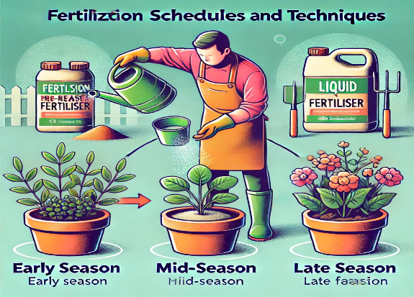

Fertilization Schedules and Techniques

Because container plants quickly deplete nutrients, it's important to create a fertilization schedule that keeps your plants healthy throughout the growing season.

Fertilizing Schedules for Container Plants:
- Leafy Greens: Use a nitrogen-rich water-soluble fertilizer every 2–3 weeks to promote rapid leafy growth.
- Tomatoes and Peppers: Apply a balanced slow-release fertilizer (e.g., 10-10-10) at planting time, and then every 4–6 weeks to encourage fruiting and overall plant health.
- Herbs: Fertilize with organic compost tea or a diluted liquid fertilizer monthly to support continuous growth.
- Flowers: Feed flowering plants with a balanced fertilizer (e.g., 20-20-20) every 3–4 weeks to enhance blooming and foliage health.
- Root Vegetables: Apply bone meal or a phosphorus-heavy fertilizer at planting and mid-season to support root development.

Techniques for Effective Fertilization:
- Top-Dressing: Add organic fertilizers such as compost or worm castings to the top of the soil. As you water, the nutrients will slowly filter down to the root zone.
- Foliar Feeding: Apply liquid fertilizer directly to the leaves. This method is particularly effective for addressing nutrient deficiencies quickly.
- Drip Fertilization: For larger containers, drip irrigation systems deliver a diluted fertilizer solution directly to the roots, ensuring even distribution without over-fertilizing.

Practical Tip: For young plants, dilute water-soluble fertilizers to half strength to avoid overwhelming the roots. As the plants mature, you can increase the concentration.

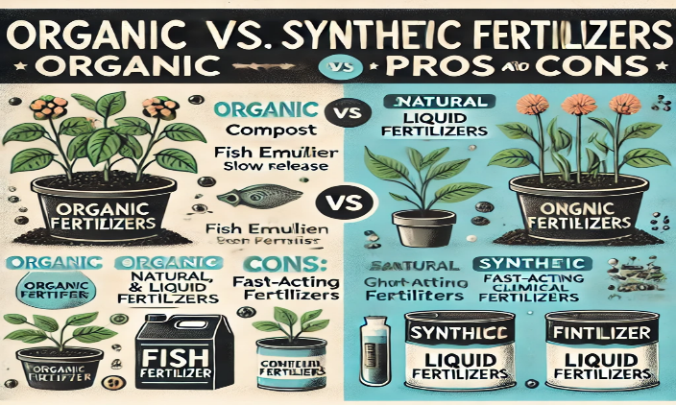

Organic vs. Synthetic Fertilizers: Pros and Cons

Both organic and synthetic fertilizers have benefits, but they also come with trade-offs. Understanding these will help you choose the best option for your container plants.

Organic Fertilizers:
- Pros:
  - Improve soil structure and encourage healthy microbial life.
  - Slow-release reduces the risk of over-fertilization.
  - Environmentally sustainable and non-toxic.
- Cons:
  - Nutrients are not immediately available and may take time to break down.
  - May require more frequent applications to maintain nutrient levels.

Synthetic Fertilizers:
- Pros:
  - Provide nutrients that are immediately available to plants.
  - Precise nutrient ratios can target specific plant needs.
  - Fast-acting and effective for correcting deficiencies.
- Cons:
  - Overuse can lead to salt buildup and nutrient imbalances.
  - Do not improve soil structure or support microbial life.
  - Can contribute to environmental harm if excess fertilizer leaches into waterways.

Scientific Insight: While synthetic fertilizers offer quick results, they don’t contribute to the long-term health of the soil. Organic fertilizers, on the other hand, build soil structure and promote a sustainable growing environment over time.
Practical Tip: For best results, consider combining organic and synthetic fertilizers. Use organic fertilizers for long-term soil health and synthetic fertilizers for rapid growth or fruiting periods.

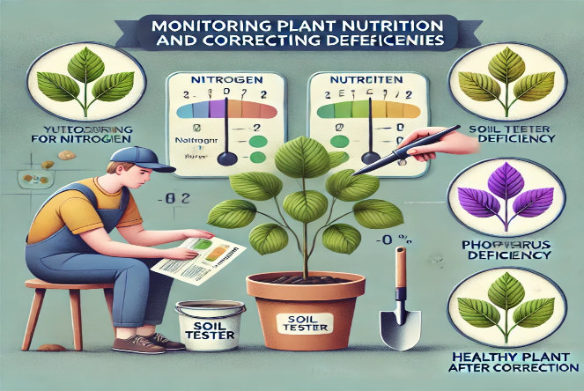

Monitoring Plant Nutrition and Correcting Deficiencies

Even with regular fertilization, container plants may show signs of nutrient deficiencies. Early detection allows for quick corrective action.

Common Nutrient Deficiency Symptoms:
- Nitrogen Deficiency: Yellowing of older leaves and stunted growth. Apply a nitrogen-rich fertilizer (e.g., fish emulsion).
- Phosphorus Deficiency: Purple discoloration of leaves, particularly in cooler weather. Add bone meal or a phosphorus-rich fertilizer.
- Potassium Deficiency: Browning or yellowing of leaf edges, especially in older leaves. Apply potassium sulfate or a balanced N-P-K fertilizer.
- Iron Deficiency: Yellowing of younger leaves with green veins. Use iron supplements or chelated iron.

Practical Tip: Regularly monitor your plants and adjust the fertilization schedule based on growth patterns and nutrient needs. Keeping a log of fertilization activities can help fine-tune your approach over time.

Nutrient Deficiency
  Symptoms
  Corrective Actions
 | Yellowing of older leaves, stunted growth | Apply a nitrogen-rich fertilizer or compost
  Nitrogen Deficiency
 | Purpling of leaves, especially on the underside, slow growth | Use a phosphorus-rich fertilizer or bone meal
  Phosphorus Deficiency
Potassium Deficiency | Yellowing and browning of leaf edges, weak stems | Add potassium-rich fertilizers like wood ash or potassium sulfate
Magnesium Deficiency | Yellowing between leaf veins, older leaves affected first | Incorporate magnesium sources like Epsom salts or dolomite lime
Calcium Deficiency | Leaf tip burn, blossom end rot in fruits, distorted growth | Apply calcium-rich products like gypsum or lime
Iron Deficiency | Yellowing of new leaves with green veins, stunted growth | Use iron chelate or iron-rich foliar sprays

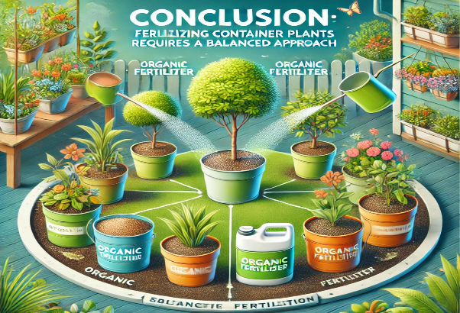

Conclusion: Fertilizing container plants requires a balanced approach

Fertilizing container plants requires a balanced approach to ensure they receive the nutrients they need without causing nutrient imbalances or soil damage. By understanding the role of different nutrients, choosing the right type of fertilizer, and following an appropriate fertilization schedule, you can create a nutrient-rich environment that supports healthy growth, vibrant flowers, and high yields. Whether you prefer organic, synthetic, or a combination of both, regular monitoring and adjustments will keep your container garden thriving throughout the growing season.

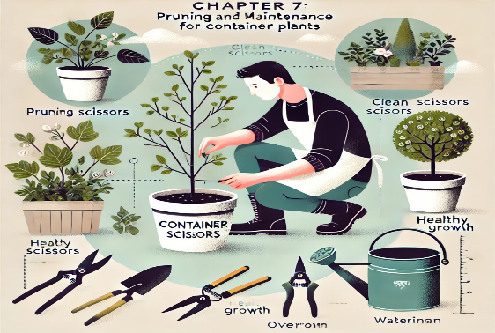

Chapter 7: Pruning and Maintenance for Container Plants

Maintaining container plants is crucial to ensure their long-term health and productivity. Proper pruning, deadheading, and routine maintenance tasks help manage plant size, encourage new growth, and prevent disease. In this chapter, we’ll explore pruning techniques, including deadheading and root pruning, and how to maintain container plants effectively for maximum beauty and productivity.

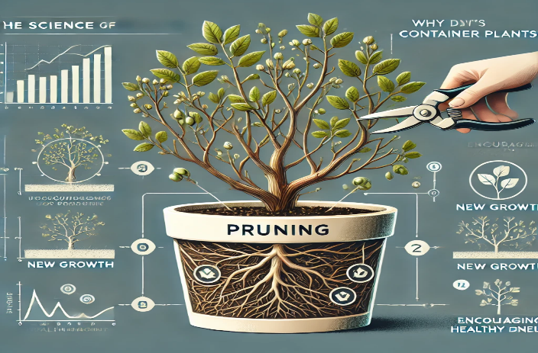
  - The Science of Pruning: Why It’s Important for Container Plants

Why Pruning Matters: Pruning is essential for controlling the size and shape of plants, especially in containers where space is limited. Pruning removes dead or diseased branches, encourages healthy growth, and stimulates the production of flowers and fruit.

Scientific Insight: Pruning stimulates the plant’s production of growth hormones such as auxin, which is produced in the tips of stems. By cutting back certain parts of the plant, you alter the flow of auxin, encouraging the plant to focus its energy on producing new shoots, flowers, and fruit.

Key Takeaway: Pruning is essential in container gardening to maintain plant size, shape, and health. It also directs the plant’s energy into producing more flowers or fruit instead of excess foliage.

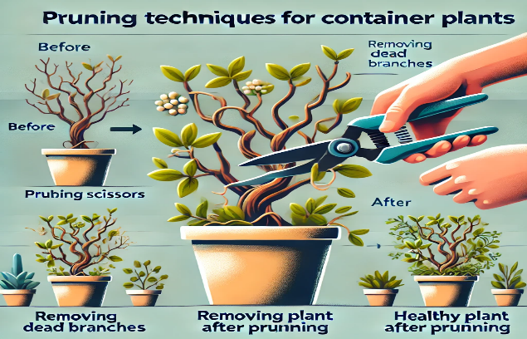
  - Pruning Techniques for Container Plants

Pruning techniques vary depending on the plant type and your goals for growth and productivity. Here are some key pruning methods to maintain healthy container plants.

Pinching Back

What Is Pinching Back?: Pinching back refers to the removal of the growing tips of stems. This encourages the plant to grow bushier by promoting side shoots and reducing legginess.

- When to Pinch: Pinch back plants like herbs (basil, mint, oregano) and flowers (petunias, geraniums) early in their growth to encourage branching and prevent them from becoming tall and spindly.
- How to Pinch: Use your thumb and forefinger to gently remove the soft tips of stems just above a leaf node.

Scientific Insight: Pinching disrupts apical dominance, where the main growing tip suppresses the growth of lateral buds. Removing the main tip encourages the plant to focus on growing lateral branches, resulting in a fuller, bushier appearance.
Practical Tip: Regularly pinch back herbs like basil and mint to keep them bushy and prevent them from flowering, which can negatively affect flavor.

    - Deadheading

What Is Deadheading?: Deadheading is the removal of spent or dead flowers from plants. This prevents the plant from wasting energy on seed production and encourages the growth of new flowers.

- When to Deadhead: Perform deadheading throughout the growing season, particularly on flowering plants like marigolds, geraniums, petunias, and zinnias.
- How to Deadhead: Use clean, sharp scissors or pruning shears to snip off dead or fading flowers just above a leaf or bud.

Scientific Insight: Deadheading prevents the plant from entering its reproductive phase, where energy is diverted to seed production. By removing spent flowers, you encourage the plant to focus on producing new blooms, extending the flowering period.
Practical Tip: Regular deadheading can keep flowering plants blooming all season long, enhancing both the health and aesthetic of your container garden.

Thinning and Shaping

What Is Thinning?: Thinning involves selectively removing some branches or stems to reduce overcrowding. This improves air circulation and light penetration, which helps prevent disease and promotes healthy growth.

- When to Thin: Thin out plants like tomatoes, peppers, and eggplants when they become too dense. Additionally, thinning seedlings helps prevent overcrowding in small containers.
- How to Thin: Cut back weak, spindly, or crossing branches at their base to open up the plant and allow for better air circulation.

Scientific Insight: Thinning improves airflow around the plant, reducing the risk of fungal infections like powdery mildew and root rot. It also allows more light to reach all parts of the plant, encouraging even growth.
Practical Tip: Thin fruit-bearing plants like tomatoes early in the season to prevent overcrowding and to direct the plant’s energy toward producing healthy fruits.

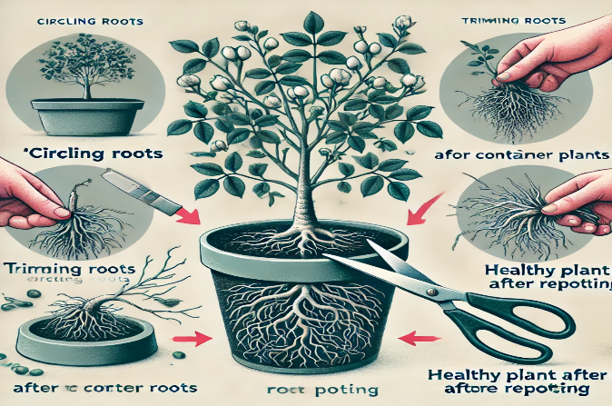

Root Pruning for Container Plants

Root pruning is especially important for container plants that have been in the same pot for a long time. As plants grow, their roots can become pot-bound, circling the container and leading to stunted growth.

What Is Root Pruning?: Root pruning involves trimming back the roots of a plant to encourage new, healthy root growth and to prevent the plant from becoming root-bound.

- When to Root Prune: Root prune when you notice that the plant is becoming root-bound, which happens when roots are tightly circling the inside of the pot. This usually occurs after one or two growing seasons.
- How to Root Prune: Remove the plant from the container and gently loosen the root ball. Using sharp, clean scissors or a knife, trim away 1/3 of the outer roots. Repot the plant with fresh soil in the same or a slightly larger container.

Scientific Insight: Root pruning promotes the growth of new feeder roots, which are responsible for absorbing water and nutrients. This keeps the plant healthy and prevents it from becoming stunted due to restricted root space.
Practical Tip: Perform root pruning during the plant’s dormant phase or at the beginning of the growing season to minimize shock. After root pruning, water the plant thoroughly to help it recover.

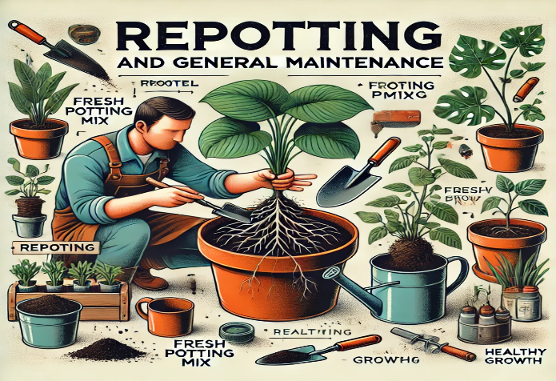
  - Repotting and General Maintenance

Why Repotting is Necessary: Repotting is essential for container plants that have outgrown their containers or when the soil has become depleted of nutrients. Repotting provides the plant with fresh soil and room for root expansion.

- When to Repot: Repot plants every one to two years or when you notice that the roots are circling the bottom of the pot or growing out of the drainage holes.
- How to Repot: Gently remove the plant from its container, loosen the roots, and repot it in fresh soil, using a container that is 1–2 inches larger in diameter.

General Maintenance Tasks for Container Gardens:
- Mulching: Apply a layer of organic mulch (such as compost or bark chips) to the top of the soil to retain moisture and suppress weeds.
- Cleaning: Regularly remove dead leaves and debris from around the plant to prevent disease and pests.
- Pest Control: Inspect plants regularly for pests like aphids, spider mites, and whiteflies. Treat infestations early with organic insecticidal soap or neem oil.
- Soil Refreshing: Each season, top off your containers with fresh compost or potting mix to replenish nutrients lost through watering.

Practical Tip: Repot plants early in the growing season when they are most resilient. Avoid repotting during extreme heat or cold to reduce stress on the plant.

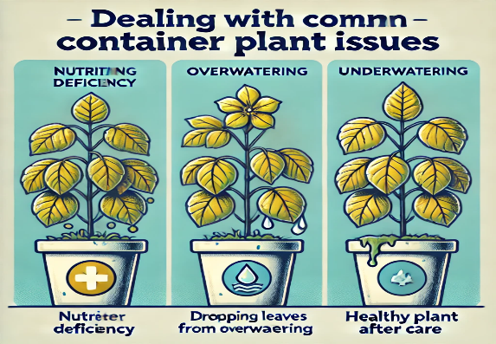

Dealing with Common Container Plant Issues

Even with proper care, container plants can experience a range of issues that require maintenance.

Legginess:
- Cause: Insufficient light or lack of pruning can cause plants to become leggy, with long, spindly stems and sparse foliage.
- Solution: Move the plant to a brighter location and pinch back the stems to encourage bushier growth.
Root Rot:
- Cause: Overwatering or poor drainage leads to waterlogged soil, which can suffocate the roots and cause root rot.
- Solution: Remove the affected plant from its pot, trim away rotted roots, and repot in fresh, well-draining soil. Adjust your watering schedule to allow the soil to dry out between waterings.

Yellowing Leaves:
- Cause: Nutrient deficiencies, overwatering, or poor drainage can cause leaves to turn yellow.
- Solution: Check the soil for moisture content and nutrient levels. Fertilize appropriately, ensuring that the plant receives the necessary nutrients like nitrogen, magnesium, and iron.

Practical Tip: Keep a maintenance log for each plant, recording when you prune, repot, fertilize, and water. This helps you track the health of your plants and anticipate maintenance needs before problems arise.

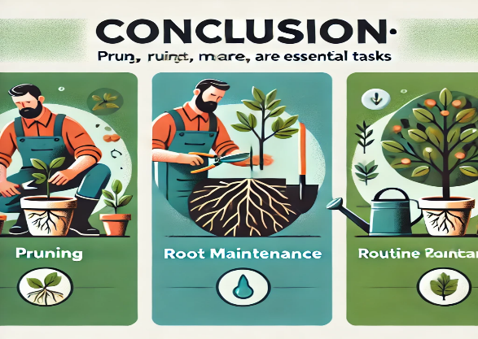

Conclusion: Pruning, root maintenance, and routine care are essential tasks

Pruning, root maintenance, and routine care are essential tasks for keeping container plants healthy, productive, and visually appealing. By using proper pruning techniques, repotting when necessary, and addressing common issues promptly, you can ensure that your container garden thrives throughout the growing season.

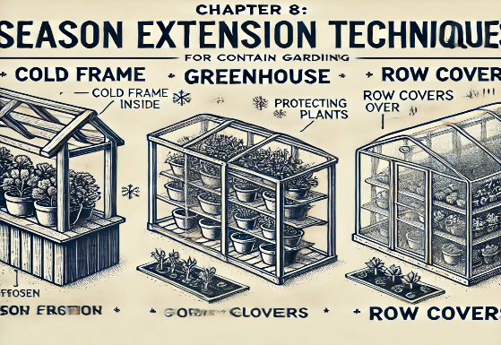

Chapter 8: Season Extension Techniques for Container Gardening

Season extension techniques allow gardeners to grow plants beyond the typical growing season by providing protection from cold temperatures and frost. This is especially important for container gardeners who want to maximize their harvest or maintain year-round gardens. In this chapter, we will explore various methods to extend the growing season, including the use of cold frames, greenhouses, and overwintering container plants. We'll also cover succession planting and how to manage container gardens through the changing seasons.

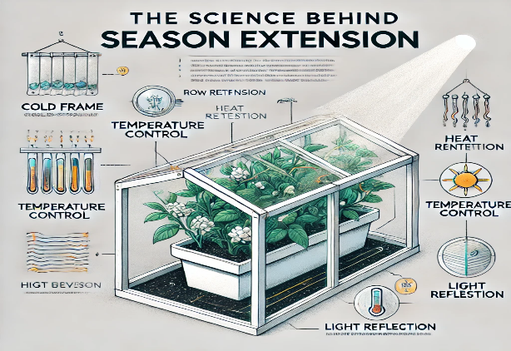

The Science Behind Season Extension

Why Season Extension is Important: In many regions, the growing season is limited by frost dates and temperature fluctuations. Season extension techniques enable gardeners to extend the period in which plants can thrive by protecting them from the cold and maintaining optimal growing conditions.

Scientific Insight: Plants require a minimum temperature for active growth, and exposure to frost can damage plant cells, particularly in tender species. By manipulating the microclimate around your container garden, you can maintain warmer conditions, prolonging the growing season.

Key Takeaway: Season extension is essential for achieving continuous harvests, growing out-of-season crops, and protecting sensitive plants from frost damage.

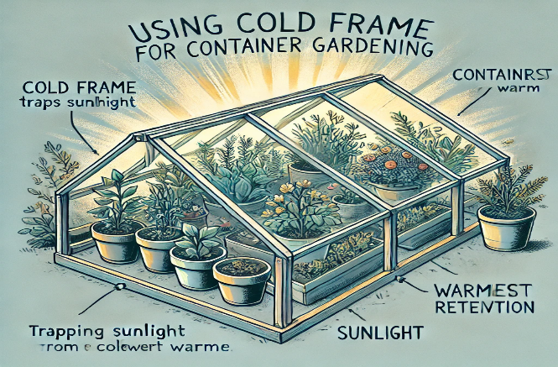
  - Using Cold Frames for Container Gardening

What Is a Cold Frame?: A cold frame is a simple structure with transparent walls and a lid that traps heat, creating a warmer microclimate. It can be used to protect container plants from cold temperatures, particularly in the early spring or late fall.

How Cold Frames Work:
- Heat Retention: The clear lid allows sunlight to penetrate, warming the air and soil inside. The trapped heat raises the temperature, allowing plants to grow even when outside temperatures are cold.
- Frost Protection: Cold frames protect plants from frost by maintaining a warmer environment inside, even during cold nights.

Building a Cold Frame for Containers:
- Materials: Use wood or bricks for the frame and a clear material (e.g., glass, plastic, or acrylic) for the lid.
- Placement: Position the cold frame in a sunny spot, preferably facing south to maximize sunlight exposure.
- Ventilation: On warmer days, prop open the lid to allow airflow and prevent overheating.

Practical Tip: For small container gardens, cold frames are an easy and inexpensive way to extend the growing season for vegetables like lettuce, spinach, and herbs.

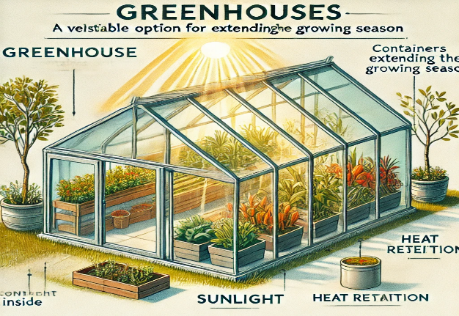

Greenhouses: A Versatile Option for Extending the Growing Season

What Is a Greenhouse?: Greenhouses are enclosed structures that create a controlled environment for plant growth. They offer the most flexibility in season extension by providing warmth, humidity control, and protection from the elements.

Greenhouse Benefits for Container Gardening:
- Temperature Regulation: Greenhouses trap heat, maintaining a warm environment even during cold weather.
- Humidity Control: Greenhouses allow you to control humidity levels, preventing plants from drying out in cold, dry conditions.
- Year-Round Growing: With supplemental heating and lighting, greenhouses can support plant growth year-round, making them ideal for container gardens.

Types of Greenhouses for Container Gardens:
- Mini Greenhouses: Small, portable structures perfect for balconies, patios, or small gardens.
- Polytunnels: Larger, semi-permanent structures made from plastic sheeting stretched over a metal frame. Ideal for gardeners who want more space but don’t need a full-sized greenhouse.
- Traditional Glass Greenhouses: Permanent structures made from glass and metal, offering the best control over temperature, light, and humidity.

Practical Tip: Mini greenhouses are ideal for small container gardens. They are affordable, easy to set up, and can extend the growing season for delicate plants like tomatoes, peppers, and herbs.

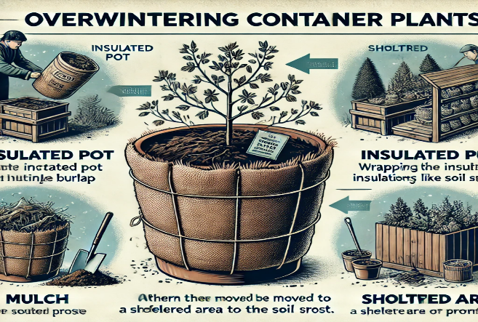

Overwintering Container Plants

What Is Overwintering?: Overwintering involves protecting plants during the winter months so they can survive until the next growing season. This is particularly useful for perennials, shrubs, and trees grown in containers that are sensitive to frost.

Steps for Overwintering Container Plants:
- Move Containers Indoors: Bring tender plants like herbs, succulents, and houseplants indoors before the first frost.
- Insulate Containers: For hardier plants that can stay outdoors, wrap containers with bubble wrap or burlap to insulate the roots and prevent freezing.
- Mulch the Soil: Add a layer of mulch (such as straw, leaves, or bark) to the top of the soil to insulate and retain warmth.
- Reduce Watering: Many plants go dormant during the winter, so reduce watering to avoid waterlogging, which can lead to root rot.
- Provide Supplemental Light: If overwintering indoors, place plants near a bright window or use grow lights to provide adequate light for continued growth.

Practical Tip: Choose frost-hardy perennials and shrubs for your containers if you plan to overwinter them outdoors. Plants like rosemary, lavender, and some dwarf fruit trees can survive cold temperatures with the proper care.

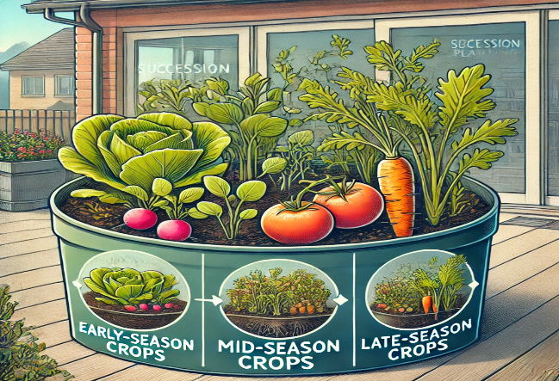
  - Succession Planting in Containers

What Is Succession Planting?: Succession planting is a method of planting crops in intervals to ensure continuous harvests throughout the growing season. In container gardening, this can help maximize space and productivity by growing multiple crops in the same container at different times of the year.

How to Implement Succession Planting:
- Early-Season Crops: Start with cool-season crops like lettuce, spinach, and radishes in the early spring.
- Mid-Season Crops: After harvesting early crops, replant the same containers with warm-season crops like tomatoes, peppers, and basil in late spring or early summer.
- Late-Season Crops: Once warm-season crops are harvested, transition to late-season crops like kale, beets, and carrots in the fall.

Scientific Insight: Succession planting takes advantage of the different growth cycles of plants. By rotating crops, you avoid depleting the soil of specific nutrients, and you maintain continuous production without letting containers sit idle.
Practical Tip: Plan your succession planting around your local frost dates. Start cool-season crops indoors or in cold frames to get a head start on the growing season, then transition to warm-season crops as the weather warms.

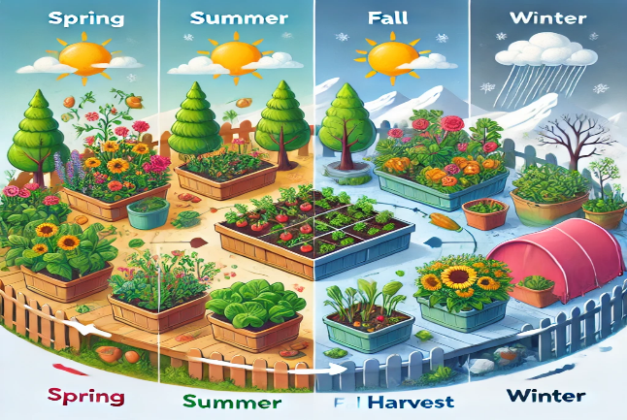
  - Managing Container Gardens Through Seasonal Changes

Spring:
- Start Early: Use cold frames or greenhouses to start seeds early in the season. As temperatures rise, move containers outdoors gradually to acclimate plants to the weather.
- Fertilize and Repot: Early spring is the ideal time to refresh the soil in your containers and add organic fertilizer to support new growth.

Summer:
- Water Frequently: In hot weather, containers dry out quickly, so water deeply and often, especially for thirsty crops like tomatoes and peppers.
- Provide Shade: If temperatures soar, move containers to shaded areas or provide shade cloth to prevent plants from overheating.

Fall:
- Extend the Season: Use season extension techniques like cold frames or mini greenhouses to protect late-season crops from early frosts.
- Prepare for Overwintering: Prune plants, reduce watering, and begin overwintering steps for tender or frost-sensitive container plants.

Winter:
- Protect Containers: Insulate pots, mulch the soil, and move plants indoors or to sheltered locations as needed. Keep a close eye on watering, as overwatering in winter can cause root rot.

Practical Tip: Keep a gardening calendar to track planting dates, frost dates, and seasonal tasks like fertilizing, repotting, and pruning. This will help you plan effectively for year-round container gardening.

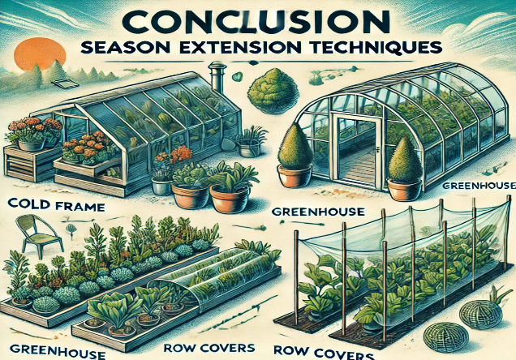
  - Conclusion: Season extension techniques

Season extension techniques are valuable tools for container gardeners who want to prolong their growing season and enjoy fresh produce year-round. Whether you use cold frames, greenhouses, or overwintering methods, these strategies allow you to protect your plants from cold weather and maximize your harvest. By planning ahead and managing your container garden through seasonal changes, you can enjoy continuous growth and productivity.

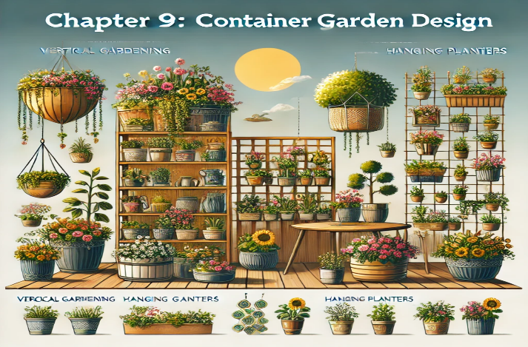

Chapter 9: Container Garden Design

Designing a container garden involves more than just selecting plants and pots—it’s about creating visually appealing combinations that enhance your outdoor or indoor space while promoting healthy plant growth. In this chapter, we’ll explore the principles of container garden design, focusing on plant selection, arrangement, color theory, and vertical gardening techniques. We’ll also cover how to incorporate containers into your overall landscape design for a cohesive and functional garden space.

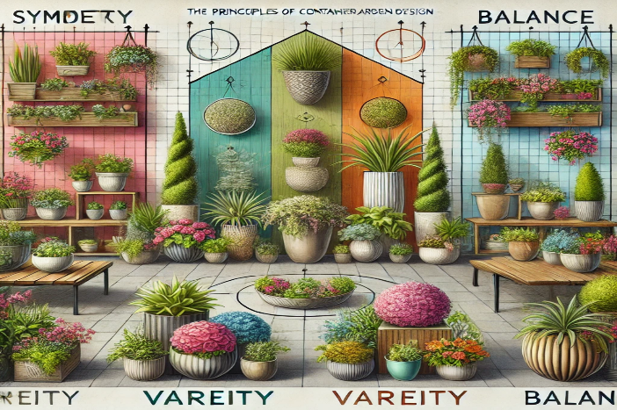

The Principles of Container Garden Design

Why Design Matters: A well-designed container garden can transform a small space into a lush, vibrant oasis. Proper plant combinations, color coordination, and thoughtful placement can elevate the visual impact of your garden while ensuring that plants thrive in their chosen environment.

Scientific Insight: Container gardens should be designed with both aesthetic and functional goals in mind. Consider factors like light exposure, water needs, and plant growth habits to ensure that your garden not only looks beautiful but also supports healthy plant development.

Key Takeaway: Thoughtful container garden design blends aesthetics and function, ensuring that plants grow well while enhancing the overall look of your space.

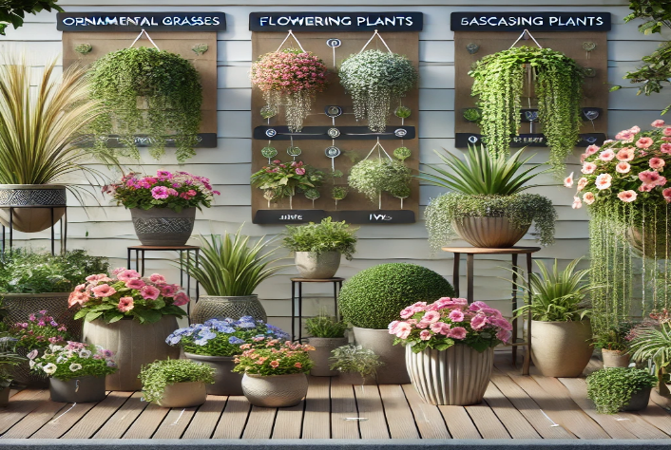

Plant Selection for Container Garden Design

Selecting the right plants for your container garden is the first step in creating an attractive and functional design. Consider plant size, growth habits, and color when choosing plants for your containers.

Thriller, Filler, Spiller Method: This classic container garden design method uses three types of plants to create a visually appealing arrangement:

- Thrillers: Tall, eye-catching plants that add height and serve as focal points. Examples include ornamental grasses, dwarf shrubs, or spiked plants like dracaena.
- Fillers: Medium-height plants that add bulk and fullness to the container, creating a sense of depth. Common fillers include petunias, begonias, or herbs like basil.
- Spillers: Trailing plants that cascade over the edges of the container, softening the overall look and adding visual interest. Popular spillers include ivy, sweet potato vine, and creeping jenny.

Scientific Insight: The thriller, filler, spiller method creates a balanced design by providing contrast in height, texture, and color. Taller plants provide structure, medium-height plants fill in gaps, and trailing plants draw the eye downward, creating a layered effect.
Practical Tip: Use containers of varying sizes and shapes to enhance the thriller, filler, spiller effect. For example, a tall, narrow container may emphasize the thriller, while a wide, shallow container works well for spillers.

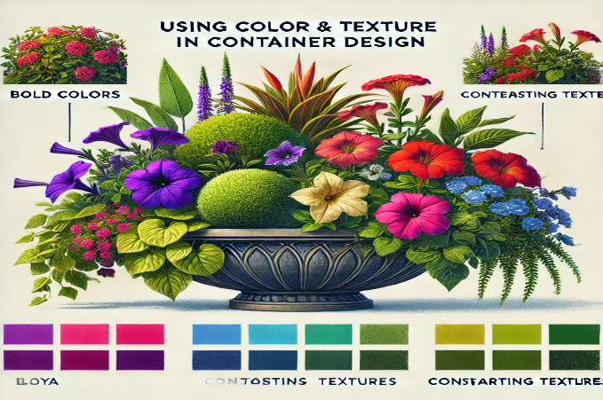

Using Color and Texture in Container Design

Color and texture play a significant role in the visual impact of a container garden. Thoughtfully combining colors and textures can create harmony, contrast, or a bold statement in your garden design.

Color Theory in Container Gardens:
- Monochromatic Color Schemes: Using different shades of the same color can create a calming, cohesive look. For example, combine deep purple petunias with lavender-colored salvia for a harmonious purple-themed container.
- Complementary Color Schemes: Colors opposite each other on the color wheel, like purple and yellow or red and green, create bold, eye-catching contrast. Pair red geraniums with trailing green sweet potato vines for a striking visual effect.
- Analogous Color Schemes: These involve using colors next to each other on the color wheel, like blue, purple, and pink, for a soft, blended look.

Texture and Form:
- Fine vs. Coarse Texture: Fine-textured plants (like ferns or grasses) create a delicate, airy effect, while coarse-textured plants (like elephant ear or succulents) add boldness and structure.
- Contrasting Forms: Mix plants with different forms, such as spiky grasses with round, mounding plants, to add visual interest. The combination of different textures and shapes keeps the design dynamic and engaging.

Scientific Insight: Colors influence mood and perception, with warm colors (red, yellow, orange) creating energy and cool colors (blue, green, purple) evoking calmness. When designing a container garden, balance warm and cool colors based on the atmosphere you want to create.
Practical Tip: Experiment with color combinations by grouping containers together before planting. This allows you to visualize how colors and textures will interact and ensures a balanced design.

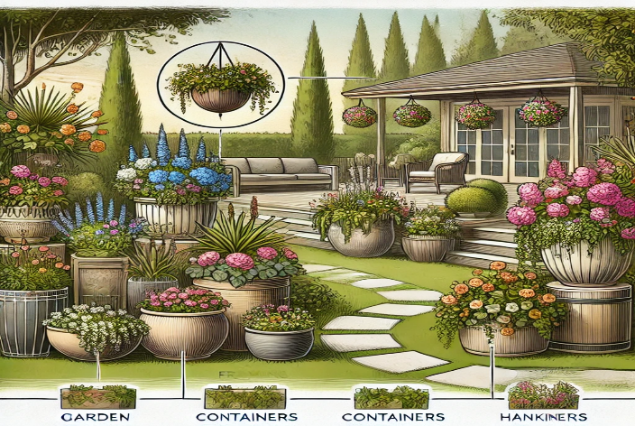

9.4 Incorporating Containers Into Landscape Design

Containers can play a significant role in landscape design, offering flexibility and mobility that traditional garden beds cannot. Incorporating containers into your landscape allows you to add color, height, and variety to any space.

Placing Containers in the Landscape:
- Focal Points: Use large, striking containers as focal points in the garden. Position them at the entrance of a patio, along a garden path, or in a corner to draw the eye and create a sense of flow.
- Grouping Containers: Arrange multiple containers together to create a cohesive display. Vary the height and size of the containers to add depth and visual interest.
- Framing: Use containers to frame specific areas, such as doorways, seating areas, or garden features like fountains. This helps define the space and create a welcoming atmosphere.
- Vertical Gardens: Use containers in vertical gardening systems (more on this below) to maximize space in small gardens or balconies.

Scientific Insight: Containers can be strategically placed to create microclimates, allowing you to grow plants that wouldn’t typically thrive in your climate. For example, placing heat-loving plants in containers near a sunny wall or patio can provide the extra warmth they need.
Practical Tip: Choose containers that complement the overall style of your landscape. For example, terracotta pots work well in Mediterranean-themed gardens, while sleek, modern containers suit contemporary spaces.

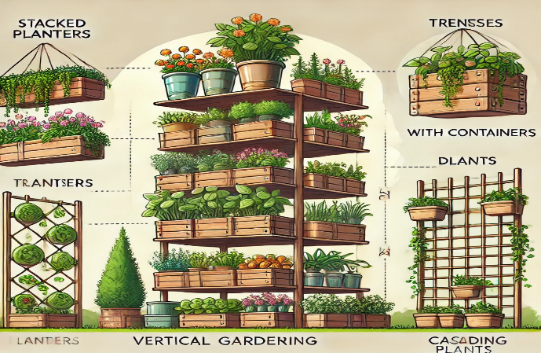

Vertical Gardening with Containers

Vertical gardening is an excellent solution for gardeners with limited space. By growing plants upward rather than outward, you can maximize your growing area while adding a dynamic element to your garden design.

Benefits of Vertical Gardening:
- Space Efficiency: Vertical gardening is ideal for small spaces like balconies, patios, or urban gardens, where ground space is limited.
- Aesthetic Appeal: Vertical gardens create living walls or cascading effects, which add depth and visual interest to any space.
- Increased Yield: Vertical gardens allow for more plants to be grown in a small area, increasing the overall productivity of your garden.

Vertical Gardening Techniques:
- Stacked Planters: Use stackable container systems that allow you to grow multiple layers of plants. Garden towers and tiered herb planters are popular options for growing a variety of plants in a small footprint.
- Hanging Baskets: Hanging baskets are perfect for trailing plants like ivy, petunias, or ferns. Hang them from walls, pergolas, or balcony railings to create a cascading effect.
- Wall-Mounted Planters: Attach small containers to vertical surfaces, such as fences or walls, to grow herbs, succulents, or small flowers. Vertical wall planters can be customized to fit the space and can hold multiple small pots or be designed with built-in pockets for planting.
- Trellises and Arbors: Climbing plants like beans, peas, cucumbers, and morning glories can be grown on trellises, arbors, or vertical frames. These structures support the plants as they grow upward, saving space and adding height to your garden.

Practical Tip: Choose plants with compact or trailing growth habits for vertical gardens. Consider water and light availability when designing your vertical garden, as the top of the structure may receive more sun and dry out faster than the bottom.

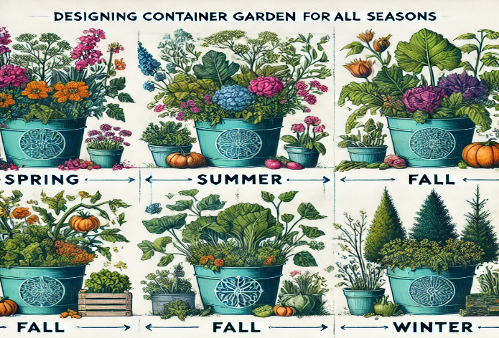

Designing Container Gardens for All Seasons

A well-designed container garden can provide year-round beauty, even during the colder months. By choosing plants that thrive in different seasons, you can ensure that your garden remains vibrant and interesting throughout the year.

Seasonal Design Tips:
- Spring: Plant cool-season flowers like pansies, snapdragons, and violas in early spring for a burst of color. Pair them with emerging perennials like tulips or daffodils.
- Summer: For summer, opt for heat-tolerant plants like geraniums, petunias, and marigolds. Mix in drought-tolerant herbs like rosemary or thyme to reduce watering needs.
- Fall: Transition to fall-themed containers with ornamental grasses, chrysanthemums, and pansies. Add pumpkins or gourds for an autumnal touch.
- Winter: In colder climates, use evergreen plants like dwarf spruce, boxwood, or holly in containers to provide structure and color during the winter months. Add decorative elements like twigs, pinecones, or holiday lights for seasonal interest.

Scientific Insight: Containers provide the flexibility to rotate plants seasonally. By switching out plants as the seasons change, you can keep your garden looking fresh and ensure that your containers are always filled with healthy, thriving plants.
Practical Tip: When designing for year-round appeal, include a mix of evergreen plants and seasonal flowers. This ensures that your containers maintain interest and structure even when annuals fade.

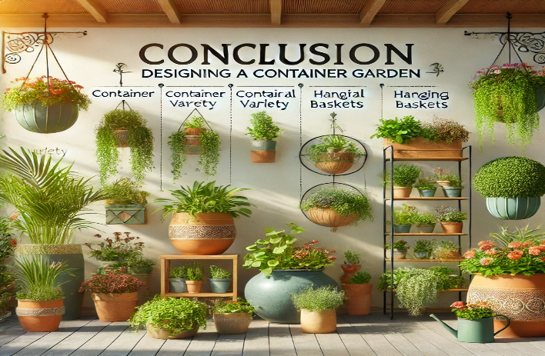
Conclusion: Designing a container garden

Designing a container garden requires careful consideration of plant combinations, color schemes, and placement. By using design principles like the thriller, filler, spiller method and incorporating vertical gardening techniques, you can create a dynamic and visually appealing garden that maximizes space and enhances your landscape. Whether you’re working with a small balcony or a large outdoor space, container gardens offer endless possibilities for creativity and beauty.

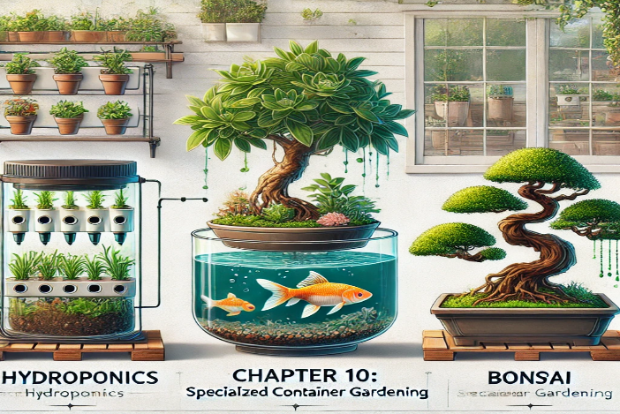

Chapter 10: Specialized Container Gardening

Specialized container gardening extends beyond traditional soil-based growing methods to include innovative systems like indoor gardening, hydroponics, aquaponics, and even bonsai and topiary techniques. These methods cater to gardeners looking for creative ways to grow plants, either indoors or with unique styling approaches. In this chapter, we will explore the science and practical applications behind each of these specialized forms of container gardening, providing detailed guidance on how to implement these systems.

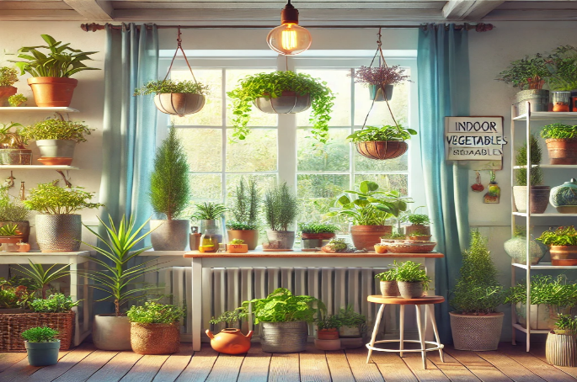
  - Indoor Container Gardening

Why Choose Indoor Container Gardening?: Indoor container gardening allows you to grow plants year-round, regardless of outdoor weather conditions. This method is ideal for urban gardeners, people with limited outdoor space, or those who want to bring nature inside.

Scientific Insight: Indoor environments present unique challenges, such as limited natural light, temperature fluctuations, and lower humidity. By controlling these factors, you can create optimal growing conditions for your indoor plants.

Key Takeaway: Indoor container gardening offers flexibility and control over environmental factors, allowing you to grow a wide variety of plants indoors, from herbs to flowers and even vegetables.

Choosing Plants for Indoor Containers

When selecting plants for indoor gardening, consider their light and humidity requirements, as well as their growth habits.

Best Plants for Indoor Containers:
- Herbs: Basil, mint, rosemary, and parsley thrive indoors with proper light and watering.
- Houseplants: Spider plants, pothos, snake plants, and peace lilies are low-maintenance plants that adapt well to indoor environments.
- Flowers: African violets, begonias, and orchids can add vibrant color to your indoor space.
- Vegetables: Dwarf varieties of tomatoes, peppers, and lettuce can be grown indoors with sufficient light, either through a sunny window or grow lights.

Practical Tip: Place indoor containers near a south-facing window for maximum sunlight exposure. Use grow lights if natural light is insufficient, especially during winter months.

Controlling Light, Temperature, and Humidity Indoors

Light: Indoor plants need ample light to thrive. Many houseplants are adapted to low light, but flowering plants and vegetables require more intense light.

- Grow Lights: Full-spectrum LED grow lights provide the necessary wavelengths for photosynthesis, mimicking natural sunlight.

Temperature: Most indoor plants prefer temperatures between 65–75°F (18–24°C). Avoid placing plants near drafts, heating vents, or cold windows, as temperature fluctuations can stress the plants.

Practical Tip: Use a digital thermometer to monitor temperature near your indoor plants, especially in winter when temperatures may drop near windows.

Humidity: Indoor air tends to be dry, especially in winter. Many houseplants, particularly tropical varieties, prefer higher humidity levels.

- Increasing Humidity: Place containers on trays filled with water and pebbles, or use a humidifier to maintain humidity levels.

Practical Tip: Group plants together to create a microclimate with higher humidity, as plants release moisture into the air through transpiration.

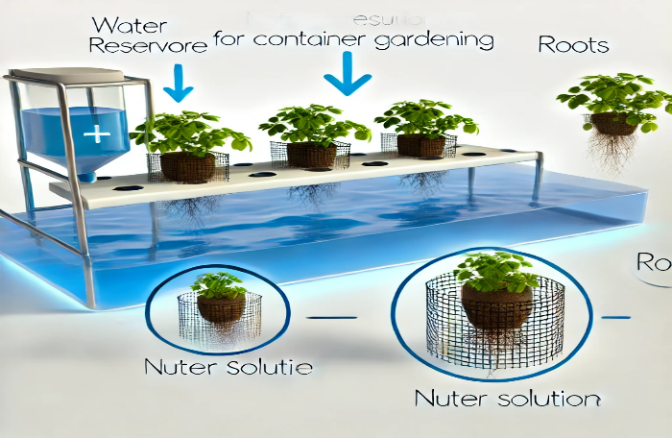

Hydroponic Systems for Container Gardening

What Is Hydroponics?: Hydroponics is a method of growing plants without soil, using nutrient-rich water to deliver essential nutrients directly to the plant roots. This method allows for faster growth, more efficient water use, and the ability to grow plants in environments where soil is not available or practical.

Scientific Insight: Hydroponic systems allow for precise control of nutrient levels, water pH, and oxygen delivery to the roots, leading to optimized growth conditions. Plants grown hydroponically often grow faster and produce higher yields than those grown in traditional soil.

Key Takeaway: Hydroponics offers an innovative, efficient way to grow plants, particularly in small spaces or in areas with poor soil quality.

Types of Hydroponic Systems

There are several hydroponic systems to choose from, each suited to different plant types and growing conditions.

- Deep Water Culture (DWC):
  - Plants are suspended in a nutrient solution with their roots submerged in water. An air pump provides oxygen to the roots, preventing them from suffocating.
  - Best for: Lettuce, spinach, and herbs.

Practical Tip: Ensure the water is well-aerated with an air stone to provide oxygen to the roots.

- Nutrient Film Technique (NFT):
  - A shallow stream of nutrient solution flows over the roots, providing nutrients while allowing the roots to access oxygen.
  - Best for: Leafy greens and strawberries.

Practical Tip: Keep the system sloped slightly to ensure even water flow across all plants.

- Wick System:
  - Nutrients are drawn up from a reservoir into the growing medium via a wick. This is a passive system with no need for pumps.
  - Best for: Small plants like herbs or lettuce.

Practical Tip: Choose a growing medium like perlite or coco coir that has good wicking properties.

- Ebb and Flow (Flood and Drain):
  - A timed pump floods the plant roots with nutrient solution before allowing it to drain back into the reservoir.
  - Best for: A wide variety of plants, including tomatoes, cucumbers, and peppers.

Practical Tip: Ensure the flood cycle is short enough to avoid root rot, but long enough to allow the roots to absorb nutrients.

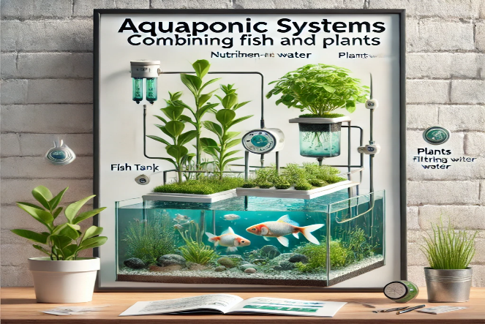

Aquaponic Systems: Combining Fish and Plants

What Is Aquaponics?: Aquaponics is a combination of aquaculture (raising fish) and hydroponics. Fish waste provides natural fertilizer for plants, while plants filter and clean the water for the fish. This creates a self-sustaining, closed-loop system.

Scientific Insight: Aquaponic systems mimic natural ecosystems, where nutrient-rich water supports plant growth, and plants help purify the water. This symbiotic relationship allows for efficient nutrient cycling, reducing the need for synthetic fertilizers.

Key Takeaway: Aquaponics offers a sustainable and eco-friendly way to grow food while raising fish, making it ideal for those looking to implement self-sustaining systems in small spaces.

Setting Up an Aquaponic System

- The Fish Tank: Choose a tank size based on the number and type of fish. Tilapia, goldfish, and koi are popular choices for aquaponics due to their hardiness.
- The Grow Bed: Plants grow in a hydroponic bed filled with a growing medium (e.g., gravel or clay pellets) above the fish tank.
- The Water Cycle: A pump circulates water from the fish tank to the grow bed, where plants absorb nutrients from fish waste before the clean water returns to the fish tank.

Practical Tip: Monitor water pH levels, as both fish and plants require specific pH ranges for optimal health (usually between 6.8 and 7.2 for aquaponics systems).

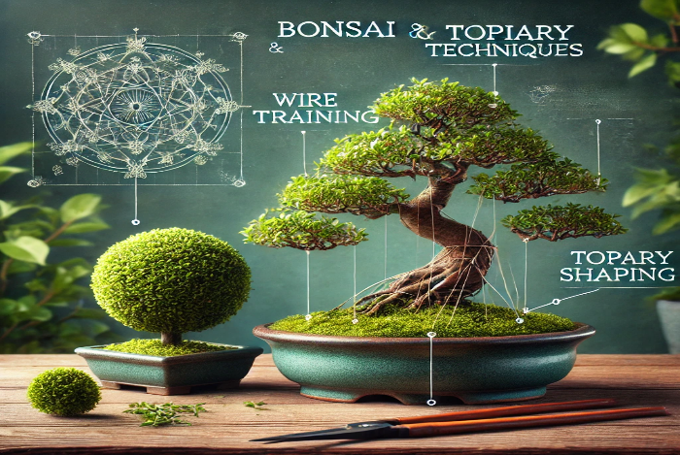

Bonsai and Topiary Techniques

What Is Bonsai?: Bonsai is the ancient art of growing miniature trees in containers, using pruning, wiring, and shaping techniques to mimic the appearance of full-sized trees.
Scientific Insight: Bonsai trees require careful root and branch pruning to maintain their small size while promoting healthy growth. Regular root pruning keeps the tree small, while careful shaping encourages specific growth patterns.

Key Takeaway: Bonsai offers a meditative, artistic approach to container gardening that requires patience and attention to detail.

Bonsai Care and Maintenance

- Pruning: Regular pruning of both roots and branches is essential to maintain the tree’s size and shape. Use sharp, sterilized tools to prevent infection.
- Wiring: Gently wrap wire around branches to guide them into the desired shape. The wire should be removed once the branch holds its form.
- Repotting: Repot bonsai trees every 2–3 years, trimming the roots and replacing the soil to ensure continued health and growth.

Practical Tip: Bonsai trees are sensitive to changes in light, temperature, and water. Place them in a location with indirect sunlight, and water consistently to keep the soil moist but not waterlogged.

Topiary

What Is Topiary?: Topiary involves shaping plants into ornamental shapes, such as spheres, spirals, or animal figures, through careful pruning and trimming.

Best Plants for Topiary:
- Boxwood: A popular choice for topiary due to its dense foliage and ability to withstand frequent pruning.
- Privet: Another great option for creating detailed shapes.
- Rosemary: For smaller, herb-based topiary.

Practical Tip: Regular trimming is necessary to maintain the shape of topiary plants. Begin with simple shapes like spheres or cones before attempting more intricate designs.

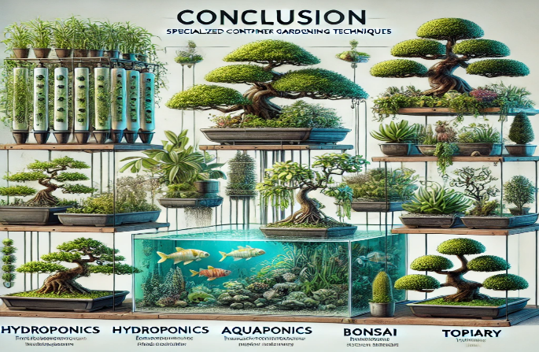

Conclusion: Specialized container gardening techniques

Specialized container gardening techniques, such as indoor gardening, hydroponics, aquaponics, bonsai, and topiary, offer exciting opportunities for gardeners to explore new methods and styles. Whether you're interested in growing plants without soil, creating self-sustaining ecosystems, or shaping trees into living art, these specialized techniques provide a unique way to expand your gardening skills and add beauty to your home or garden.

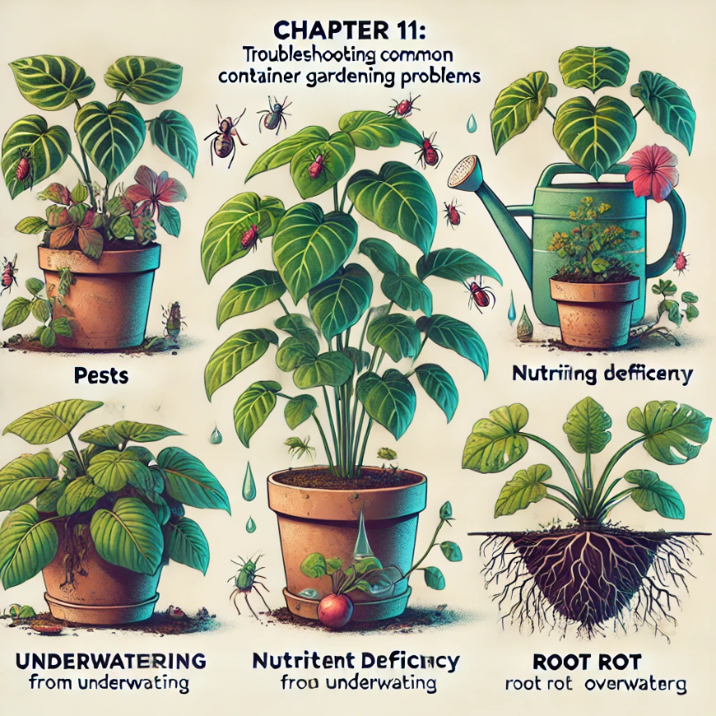

Chapter 11: Troubleshooting Common Container Gardening Problems

Even with proper care and attention, container plants can experience a range of issues, from pests and diseases to nutrient deficiencies and environmental stress. Identifying and addressing these problems early is key to maintaining a healthy and productive container garden. In this chapter, we will explore common problems that arise in container gardening, how to diagnose them, and practical solutions to restore plant health.

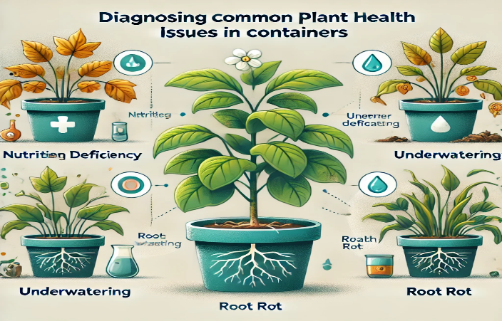

Diagnosing Common Plant Health Issues in Containers

Container plants are more vulnerable to certain issues due to the confined growing space and the reliance on limited soil for nutrients and water. Here are the most common problems and how to recognize them.

Wilting

Symptoms: Leaves appear limp and droopy, often accompanied by dry or overly wet soil.

- Cause: Wilting can be caused by both underwatering and overwatering. In underwatering, the plant lacks sufficient moisture, leading to dehydration. Overwatering, on the other hand, causes root rot, where the roots are unable to absorb water.
- Solution:
  - Underwatering: Water thoroughly until water runs out of the drainage holes, and make sure the plant gets consistent watering going forward.
  - Overwatering: Let the soil dry out completely before the next watering, and ensure that the container has proper drainage to prevent water from accumulating.

Practical Tip: Check soil moisture regularly by inserting your finger about an inch into the soil or using a moisture meter to ensure you are watering appropriately.

Yellowing Leaves

Symptoms: Leaves turn yellow, starting with older leaves at the base of the plant.

- Cause: Yellowing leaves are often a sign of nutrient deficiency, typically nitrogen. Overwatering or poor drainage can also cause yellowing, as it prevents roots from accessing oxygen and nutrients.
- Solution:
  - Nutrient Deficiency: Apply a balanced fertilizer or a nitrogen-rich supplement to restore nutrient levels.
  - Overwatering: Allow the soil to dry out, improve drainage, and avoid waterlogged conditions.

Scientific Insight: Nitrogen is essential for photosynthesis, and a deficiency causes chlorosis (yellowing) as the plant cannot produce enough chlorophyll.

Stunted Growth

Symptoms: Plants stop growing or grow very slowly, with small leaves or weak stems.

- Cause: Stunted growth is often due to insufficient nutrients, poor soil quality, or root-bound conditions. In some cases, a lack of sunlight or water can also lead to slow growth.
- Solution:
  - Nutrient Deficiency: Apply a slow-release fertilizer or compost to provide essential nutrients.
  - Root-Bound Plants: If the plant is root-bound, repot it into a larger container with fresh soil to give the roots room to grow.

Practical Tip: For fast-growing plants like tomatoes and peppers, check for signs of root-binding by carefully lifting the plant from its pot and inspecting the root ball.

Leaf Spotting and Blights

Symptoms: Dark spots, lesions, or yellow halos appear on the leaves, which may eventually lead to leaf drop.

- Cause: Leaf spotting is often caused by fungal or bacterial infections, which can thrive in moist, crowded conditions.
- Solution:
  - Fungal Infections: Remove infected leaves and improve air circulation around the plant. Use a fungicide if necessary, and avoid overhead watering, which can promote the spread of fungal spores.
  - Bacterial Infections: Prune away affected areas, and sanitize your pruning tools afterward to prevent further spread.

Scientific Insight: Fungal infections often occur in warm, wet environments. Improving air circulation and reducing moisture on leaves can prevent future outbreaks.

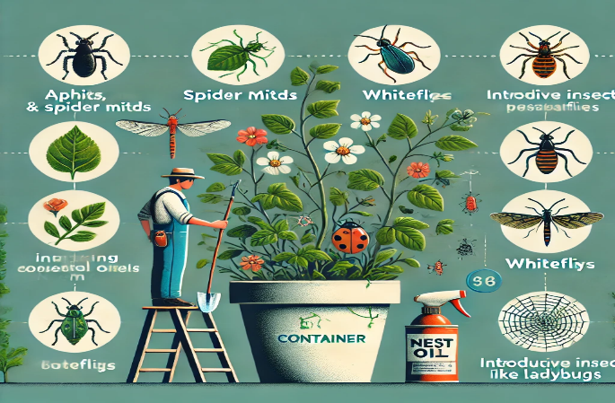

Pest Management in Container Gardens

Pests are a common problem in container gardening, especially in urban or indoor environments where natural predators may not be present. Identifying pests early and using appropriate control methods can prevent serious damage to your plants.

Aphids

Symptoms: Clusters of small, soft-bodied insects on new growth, curled leaves, or sticky "honeydew" residue on leaves.
- Cause: Aphids feed on plant sap, weakening the plant and potentially transmitting diseases.
- Solution:
  - Spray the plant with a strong stream of water to dislodge aphids.
  - Use insecticidal soap or neem oil to control the infestation.

Practical Tip: Encourage natural predators like ladybugs, which feed on aphids, by planting companion plants that attract beneficial insects (e.g., dill or marigolds).

Spider Mites

Symptoms: Tiny specks or yellow stippling on leaves, along with fine webbing between leaves or branches.

- Cause: Spider mites feed on plant sap, causing leaves to yellow and dry out.
- Solution:
  - Increase humidity around the plant, as spider mites thrive in dry conditions.
  - Spray the plant with a water-and-soap solution or neem oil to kill the mites.

Scientific Insight: Spider mites reproduce rapidly in hot, dry environments. Keeping plants well-watered and misting them regularly can help prevent infestations.

Whiteflies

Symptoms: Small white insects flying around the plant when disturbed, along with yellowing leaves and honeydew residue.
- Cause: Whiteflies feed on the underside of leaves, sucking sap and weakening the plant.
- Solution:
  - Use sticky traps to capture adult whiteflies.
  - Spray the plant with insecticidal soap or neem oil to eliminate nymphs and adults.
Practical Tip: Regularly inspect the undersides of leaves for whitefly eggs and nymphs. Early detection helps prevent large infestations.

  - Preventing and Managing Plant Diseases

Diseases in container gardens are often caused by fungal, bacterial, or viral pathogens. These diseases can spread quickly in crowded or poorly ventilated conditions, so proper care and maintenance are essential for prevention.

Root Rot

Symptoms: Wilting plants with mushy, discolored roots, often caused by overwatering or poor drainage.

- Cause: Root rot occurs when the roots sit in waterlogged soil, depriving them of oxygen and allowing fungal pathogens to thrive.
- Solution:
  - Remove the plant from its container, trim away affected roots, and repot it in fresh, well-draining soil.
  - Ensure the container has proper drainage, and adjust your watering schedule to prevent soggy soil.

Practical Tip: Adding perlite or sand to your potting mix improves drainage, reducing the risk of root rot.

Powdery Mildew

Symptoms: White, powdery spots on leaves, stems, and flowers, which can spread and cause leaves to curl and drop.

- Cause: Powdery mildew is a fungal disease that thrives in humid conditions, particularly when air circulation is poor.
- Solution:
  - Remove affected leaves, improve air circulation around the plant, and avoid overhead watering.
  - Apply a fungicide or a homemade baking soda solution (1 tablespoon baking soda per gallon of water) to prevent further spread.

Scientific Insight: Powdery mildew spores spread easily in humid environments but require dry leaf surfaces to infect plants. Keeping leaves dry and maintaining good airflow can prevent outbreaks.

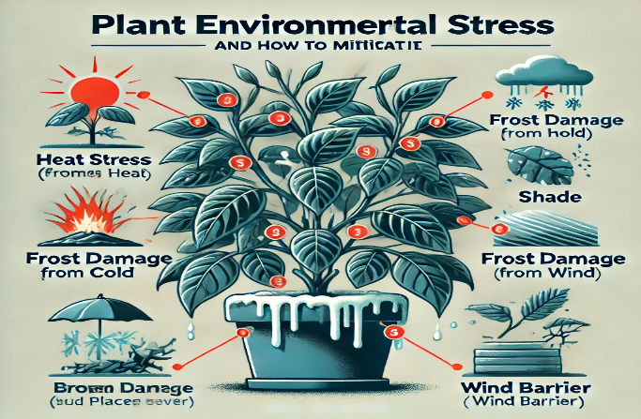

Environmental Stress and How to Mitigate It

Environmental factors, such as temperature extremes, poor light conditions, or wind exposure, can stress container plants. Learning to manage these environmental factors is key to preventing damage.

Heat Stress

Symptoms: Leaves curl or wilt during hot weather, and growth may slow down.
- Cause: High temperatures cause plants to lose water rapidly, leading to wilting and eventual heat stress.
- Solution:
  - Move containers to a shaded area during the hottest part of the day, or use shade cloth to reduce direct sunlight.
  - Water frequently to keep the soil moist, and add mulch to help retain moisture.

Practical Tip: Group containers together during heatwaves to reduce evaporation and create a microclimate that retains humidity.

Cold Stress

Symptoms: Leaves become discolored, wither, or show signs of frost damage.

- Cause: Cold temperatures, particularly below freezing, can damage tender plants and halt growth.
- Solution:
  - Move containers indoors or to a sheltered location during cold snaps.
  - Wrap containers with burlap or bubble wrap to insulate the roots from freezing temperatures.

Practical Tip: For plants that are sensitive to cold, use portable containers that can be easily moved indoors when temperatures drop.

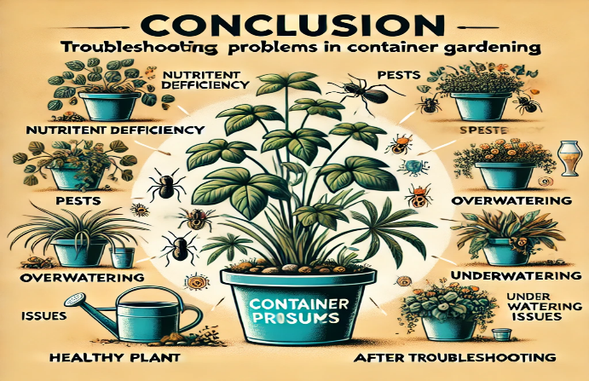

Conclusion: Troubleshooting common problems in container gardening

Troubleshooting common problems in container gardening requires careful observation and timely intervention. By understanding the symptoms of pests, diseases, and nutrient deficiencies, as well as managing environmental stress, you can maintain healthy, thriving plants. Regular inspection, proper watering, and a balanced approach to fertilization and pest control will keep your container garden in top condition.
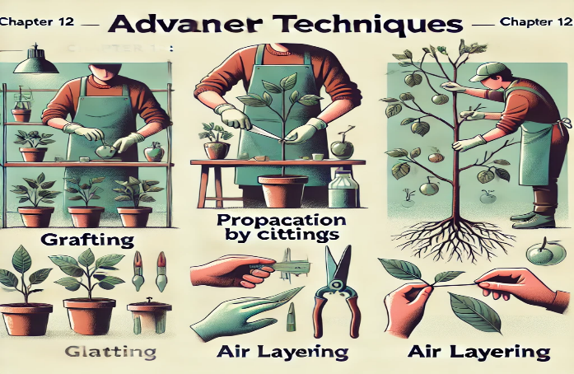

Chapter 12: Advanced Techniques for Container Gardening

For experienced gardeners looking to take their container gardening to the next level, advanced techniques such as grafting, propagation, seed starting, and creating self-sustaining ecosystems offer exciting opportunities. These methods not only enhance plant health and yield but also allow for greater creativity and experimentation. In this chapter, we will explore the science behind these advanced techniques and how to apply them to container gardening for both practical and aesthetic benefits.

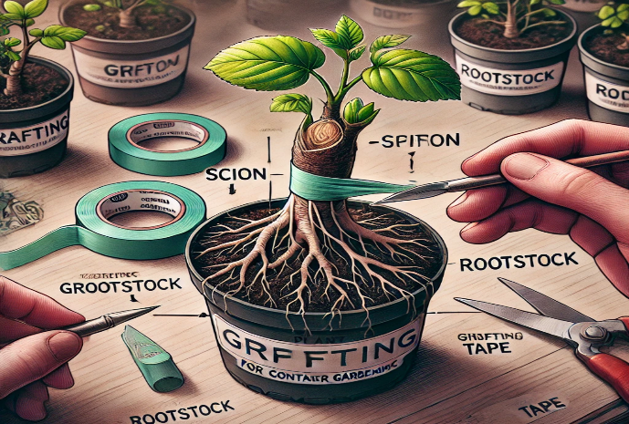

Grafting Techniques for Container Gardening

What Is Grafting?: Grafting is the process of joining two plants together so that they grow as one. Typically, a branch (scion) from a desired plant is attached to the rootstock of a compatible plant. This technique allows you to combine the best traits of both plants, such as disease resistance from the rootstock and superior fruit production from the scion.

Scientific Insight: Grafting takes advantage of the plant’s natural ability to heal. The vascular tissues of the scion and rootstock must align for successful grafting. Once the tissues fuse, nutrients and water are shared between the plants, allowing them to grow as a single unit.

Key Takeaway: Grafting can improve plant health, increase yield, and allow gardeners to grow multiple varieties of fruit or flowers on a single plant.

Types of Grafting for Container Plants

Cleft Grafting:
- How It Works: A cut is made in the rootstock, and a wedge-shaped scion is inserted into the cut. The two are bound together until they fuse.
- Best for: Fruit trees and shrubs grown in large containers.

Practical Tip: Ensure the scion and rootstock are of similar size to improve the chances of a successful graft.

Whip and Tongue Grafting:
- How It Works: Both the scion and rootstock are cut at an angle, and a small "tongue" is created in each cut to interlock the two. This creates a stronger bond than cleft grafting.
- Best for: Smaller container plants like citrus or ornamental trees.

Practical Tip: Use grafting tape to secure the scion and rootstock while they heal, and keep the grafted plant in a sheltered location to reduce stress.

Approach Grafting:
- How It Works: Two plants are grown side by side, and a section of the stem from each is cut and joined together. Once the tissues fuse, one plant’s roots or upper section is removed, leaving the grafted plant to grow.
- Best for: Vining plants like tomatoes or grapes in containers.

Practical Tip: Approach grafting works well for container plants because it allows both plants to remain rooted during the healing process, reducing the risk of graft failure.

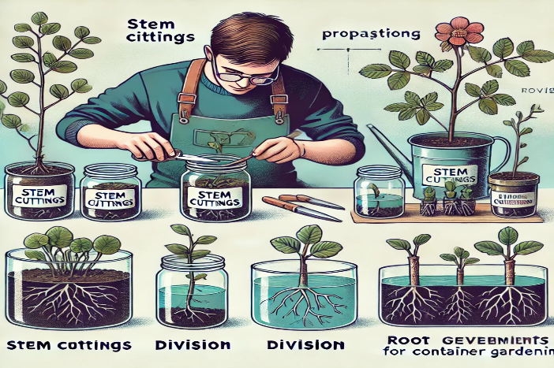

Propagation Methods for Container Gardening

Why Propagate?: Propagation allows gardeners to create new plants from existing ones, expanding their garden without the need to purchase new plants. This technique is ideal for increasing the number of plants in a container garden or for preserving heirloom varieties.

Scientific Insight: Propagation methods such as cuttings, layering, and division rely on the plant’s natural ability to regenerate from a portion of its structure. When conditions are right, cells in the cut or divided part of the plant begin to grow new roots, stems, or leaves.

Key Takeaway: Propagation is an effective way to grow new plants from your existing container garden, expanding your collection and ensuring genetic consistency.

12.2.1 Propagation by Cuttings

Stem Cuttings:
- How It Works: A section of stem (typically 4–6 inches) is cut from the parent plant, stripped of lower leaves, and placed in water or soil to encourage root growth.
- Best for: Herbs, succulents, and woody perennials like rosemary or lavender.

Practical Tip: Use a rooting hormone to stimulate root development and ensure that the cutting receives indirect sunlight and consistent moisture.

Leaf Cuttings:
- How It Works: A single leaf is removed from the parent plant and placed in moist soil. New plants will grow from the base of the leaf.
- Best for: Succulents and plants like African violets.

Practical Tip: Place the leaf flat on the soil surface and mist regularly to maintain moisture.

Propagation by Layering

Simple Layering:
- How It Works: A low-growing branch is bent to the ground and covered with soil, leaving the tip exposed. The buried section of the branch will form roots, and once established, it can be cut from the parent plant.
- Best for: Vining plants or shrubs like blueberries, raspberries, and ivy.

Practical Tip: Secure the buried section with a landscape pin or small rock to keep it in place until roots form.

Air Layering:
- How It Works: A section of stem is wounded, and moist sphagnum moss is wrapped around the wound. The moss is then covered with plastic to maintain moisture. Roots form at the wound site, allowing the branch to be cut and potted once established.
- Best for: Large houseplants or woody shrubs.

Practical Tip: Air layering is ideal for propagating larger plants that may not root easily from cuttings. Keep the moss consistently moist for the best results.

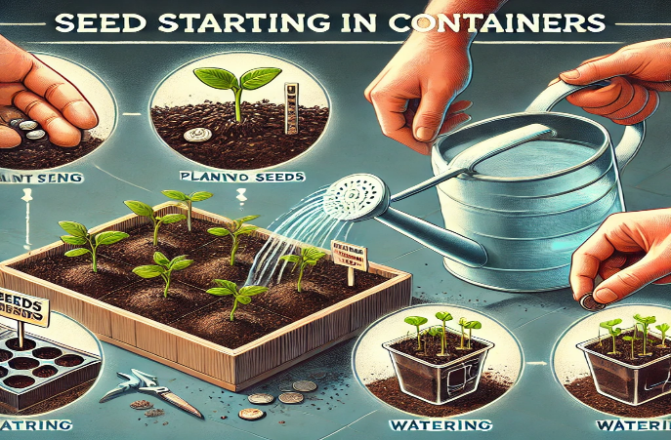

Seed Starting in Containers

Why Start from Seed?: Starting plants from seed gives gardeners greater control over plant varieties, ensures genetic diversity, and can be more cost-effective than buying seedlings. Container gardeners can start seeds indoors or outdoors, depending on the climate and the plants’ needs.

Scientific Insight: Seed germination is triggered by environmental factors such as light, moisture, and temperature. Providing the right conditions ensures that seeds germinate successfully and grow into healthy seedlings.

Key Takeaway: Seed starting allows container gardeners to experiment with a wide range of plants, including heirloom varieties and specialty plants that may not be available as seedlings.

Seed Starting Indoors

Best Seeds for Indoor Starting:
- Tomatoes, peppers, eggplants, herbs, and flowers like marigolds and zinnias are ideal candidates for indoor seed starting.

Steps for Successful Seed Starting:
- Use Seed Trays or Small Containers: Fill trays or containers with a light, sterile seed-starting mix to ensure proper drainage and aeration.
- Sow Seeds: Plant seeds at the recommended depth, typically two to three times the seed’s diameter. Mist the soil lightly to avoid displacing the seeds.
- Provide Light and Warmth: Place the seed trays near a sunny window or under grow lights. Most seeds germinate best at temperatures between 65–75°F (18–24°C).
- Keep Soil Moist: Maintain consistent moisture by covering the trays with plastic domes or cling film to create a humid environment. Remove the covers once seedlings emerge.

Practical Tip: Thin seedlings once they develop their first true leaves, allowing the strongest ones to continue growing. This prevents overcrowding and promotes healthy growth.

Direct Sowing in Containers

For certain plants, direct sowing (planting seeds directly in the container where they will grow) is the preferred method, especially for larger seeds or those sensitive to transplanting.

Best Plants for Direct Sowing:
- Beans, peas, radishes, carrots, and squash grow well when sown directly into containers.

Steps for Direct Sowing:
- Prepare the Container: Fill the container with high-quality potting mix, ensuring good drainage.
- Sow Seeds at Proper Depth: Follow the recommended depth on the seed packet, as different seeds require different planting depths.
- Water Gently: Water the container thoroughly but gently to avoid washing away the seeds. Keep the soil consistently moist as the seeds germinate.

Practical Tip: For vegetables like carrots and radishes, thin seedlings as they grow to provide enough space for proper root development.

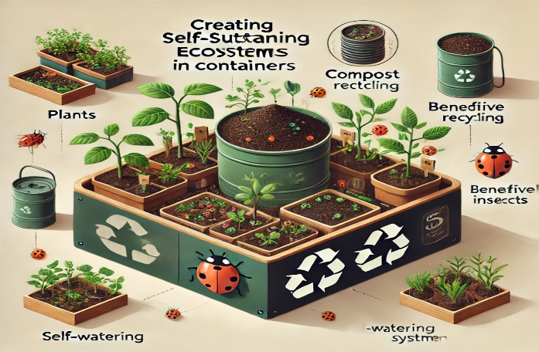

Creating Self-Sustaining Ecosystems in Containers

What Is a Self-Sustaining Container Garden?: A self-sustaining container garden mimics natural ecosystems, where plants, soil, and water systems work together to reduce the need for human intervention. These systems focus on creating a balanced environment where plants can thrive with minimal maintenance.
Scientific Insight: Self-sustaining ecosystems rely on principles of permaculture, where biodiversity, nutrient cycling, and water conservation are prioritized. By incorporating beneficial plants, organic matter, and efficient water systems, gardeners can create container gardens that require less water, fertilizer, and pest control.

Key Takeaway: Self-sustaining container gardens are eco-friendly, low-maintenance systems that promote long-term plant health and reduce the need for synthetic inputs.

Companion Planting in Containers

Why Use Companion Planting?: Companion planting involves growing certain plants together to benefit each other. Some plants repel pests, while others improve soil health or provide shade and support for neighboring plants.

Best Companion Planting Combinations:
- Tomatoes and Basil: Basil repels aphids and improves tomato flavor.
- Carrots and Onions: Onions deter carrot flies, while carrots break up the soil for better aeration.
- Beans and Corn: Beans fix nitrogen in the soil, benefiting corn, while corn provides support for climbing bean vines.

Practical Tip: Use larger containers or group smaller containers together to allow for successful companion planting in your container garden.

12.4.2 Water-Efficient Irrigation Systems

Self-Watering Containers: Self-watering containers reduce the need for frequent watering by storing water in a reservoir at the base of the container. Plants draw water up through capillary action as needed.

Drip Irrigation: Drip irrigation delivers water directly to the roots of plants, minimizing water waste and ensuring consistent moisture levels.

Practical Tip: Install a timer on your drip irrigation system to automate watering, especially during hot weather or when you’re away.

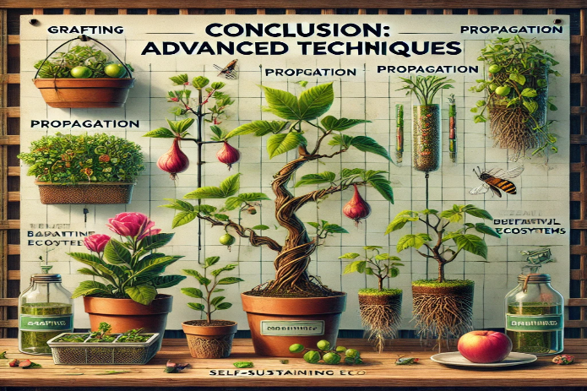

Conclusion: Advanced Techniques

Advanced techniques like grafting, propagation, seed starting, and creating self-sustaining ecosystems offer exciting opportunities for container gardeners to explore new ways of growing plants. These methods not only improve plant health and productivity but also allow for creative experimentation. By incorporating these advanced techniques into your container garden, you can achieve greater success, sustainability, and enjoyment from your gardening experience.

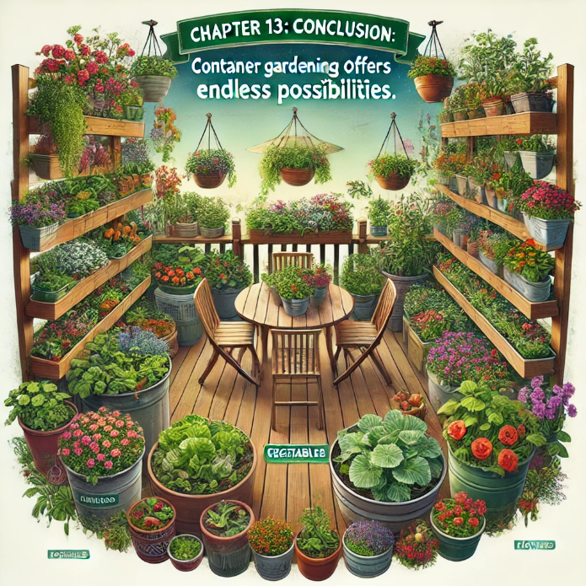

Chapter 13: Conclusion: Container gardening offers endless possibilities

Container gardening offers endless possibilities for gardeners of all skill levels, from beginners growing their first herbs on a windowsill to experienced gardeners implementing advanced techniques like grafting, hydroponics, and self-sustaining ecosystems. Throughout this book, we’ve explored the full range of container gardening—from selecting the right containers and potting mixes to mastering pruning, fertilization, and troubleshooting. We’ve also delved into specialized and advanced methods that allow gardeners to push the boundaries of what can be grown in containers.

This final chapter summarizes the core concepts covered in the book, highlighting the key takeaways and encouraging gardeners to continue experimenting and refining their container gardening practices.

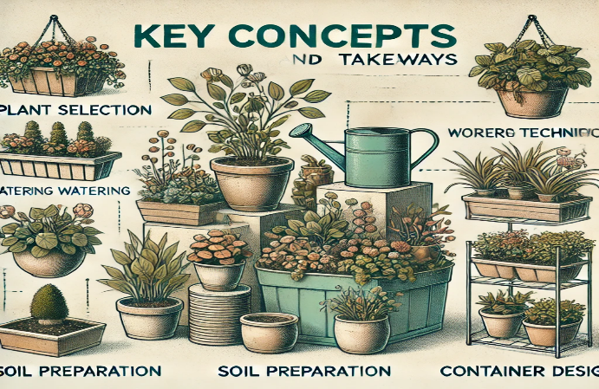

Key Concepts and Takeaways

The Foundation of Successful Container Gardening

At its core, container gardening depends on three fundamental factors: choosing the right container, using an appropriate potting mix, and managing water and nutrients effectively. By understanding the specific needs of your plants—whether they are flowers, vegetables, or herbs—you can create a thriving container garden that provides both beauty and productivity.

- Containers: Selecting the right size and material for your container ensures that plants have enough space for root development and that water drainage is adequate.
- Soil and Potting Mix: A well-balanced, well-draining potting mix provides the structure and nutrients that plants need to grow in confined spaces.
- Watering and Fertilization: Maintaining consistent moisture and providing regular fertilization keep container plants healthy and productive throughout the growing season.

Mastering Plant Selection and Maintenance

Choosing the right plants for your container garden and providing proper care, such as pruning, deadheading, and pest management, are essential for ensuring healthy growth. Container gardens can be adapted to fit any space or growing conditions, whether you are working with full sun, partial shade, or indoor environments.

- Plant Selection: Select plants based on their root system, growth habits, and light requirements. Consider using companion planting techniques to create beneficial plant partnerships.
- Pruning and Maintenance: Regular pruning and deadheading encourage new growth and improve overall plant health. Root pruning and repotting help prevent plants from becoming root-bound in their containers.

Extending the Growing Season and Advanced Techniques

Season extension methods, such as using cold frames, greenhouses, and overwintering techniques, allow gardeners to grow plants beyond the typical growing season. For those looking to explore advanced techniques, grafting, propagation, hydroponics, and aquaponics offer innovative ways to expand their container gardening skills.

- Season Extension: Use cold frames, greenhouses, and indoor spaces to protect plants from cold weather and extend the growing season.
- Advanced Techniques: Grafting, propagation, and seed starting provide opportunities to grow a wider variety of plants, while hydroponics and aquaponics offer sustainable, soil-free growing systems.

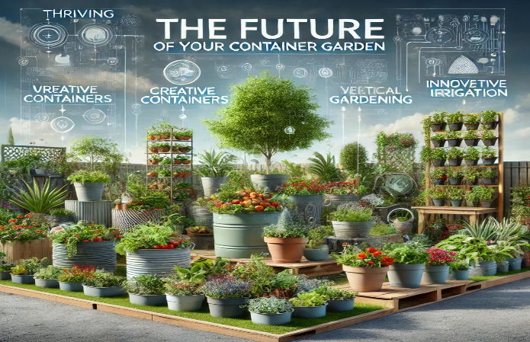

13.2 The Future of Your Container Garden

As you continue your container gardening journey, keep experimenting with new plants, designs, and techniques. Container gardening is a flexible, accessible way to bring the joys of gardening to any space, whether it’s a small urban balcony or an expansive backyard patio. By incorporating the principles and methods outlined in this book, you can create a thriving, sustainable container garden that brings you beauty, food, and satisfaction year-round.

- Sustainability: Consider incorporating more eco-friendly practices into your container gardening, such as using organic fertilizers, compost, and water-efficient irrigation systems. Creating self-sustaining ecosystems within your containers can help reduce the need for synthetic inputs and maintenance.
- Creativity: Container gardening allows for limitless creativity in design and plant selection. Continue experimenting with different container styles, vertical gardening techniques, and plant combinations to create personalized, visually stunning gardens.

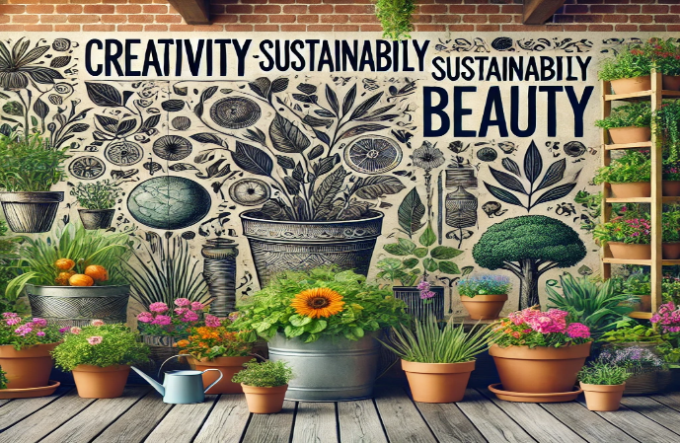

Final Thoughts: Container gardening is more than just growing plants in pots

Container gardening is more than just growing plants in pots—it's an opportunity to create lush, productive environments in even the smallest of spaces. Whether you're cultivating herbs on a windowsill, vegetables on a balcony, or a decorative flower garden in your backyard, the techniques covered in this book will help you achieve success.

Gardening is an ongoing learning process, and each season offers new challenges and rewards. By mastering the basics, exploring advanced techniques, and continually refining your approach, you will become a more knowledgeable and confident container gardener. Most importantly, enjoy the process—nurturing plants, observing their growth, and reaping the fruits of your labor is what makes gardening such a fulfilling and enriching experience.

Conclusion Summary:

This book has provided a comprehensive guide to container gardening, covering everything from the fundamentals of container selection and soil preparation to advanced techniques like grafting, hydroponics, and self-sustaining ecosystems. By applying the principles and practices outlined here, you can create a vibrant, productive container garden that suits your space, climate, and personal gardening goals. Keep experimenting, keep learning, and most of all—keep enjoying the wonders of gardening in containers.

Appendix A: Quick Reference Charts

Common Nutrient Deficiencies and Symptoms

Nutrient | Deficiency Symptoms | Solution
Nitrogen (N) | Yellowing of older leaves, stunted growth | Apply nitrogen-rich fertilizer (e.g., compost, fish emulsion)
Phosphorus (P) | Purple or dark green leaves, slow growth, poor flowering | Use bone meal or a phosphorus-rich fertilizer
Potassium (K) | Browning or yellowing leaf edges, weak stems, poor fruit development | Apply potassium sulfate or organic fertilizer
Magnesium (Mg) | Yellowing between leaf veins, starting with older leaves | Use Epsom salts or a magnesium supplement
Iron (Fe) | Yellowing of younger leaves with green veins | Apply iron chelate or foliar iron spray
Calcium (Ca) | Blossom-end rot in tomatoes and peppers, leaf tip burn | Add calcium through gypsum or lime

recommended Container Sizes for Common Plants

Plant | Minimum Container Size (Depth and Diameter)
Tomatoes | 18–24 inches deep, 18 inches wide
Peppers | 12–18 inches deep, 12 inches wide
Leafy Greens | 6–8 inches deep, 10–12 inches wide
Herbs | 6–8 inches deep, 8–10 inches wide
Carrots | 12 inches deep
Radishes | 6 inches deep
Strawberries | 8–10 inches deep
Dwarf Fruit Trees | 18–24 inches deep, 20 inches wide

Companion Planting Guide for Containers

Plant | Best Companions | Avoid Planting With
Tomatoes | Basil, marigolds, carrots | Potatoes, fennel
Peppers | Basil, onions, spinach | Fennel
Cucumbers | Beans, radishes, dill | Sage
Carrots | Onions, peas, lettuce | Dill
Beans | Corn, marigolds, cucumbers | Onions, garlic
Lettuce | Radishes, carrots, marigolds | Broccoli, cabbage

Appendix B: Troubleshooting Guide

Common Plant Issues and Solutions

Problem | Cause | Solution
Wilting (dry soil) | Underwatering | Water thoroughly until water drains from the bottom
Wilting (wet soil) | Overwatering or root rot | Let soil dry, check drainage, repot if needed
Yellowing Leaves | Nutrient deficiency (often nitrogen) | Fertilize with a balanced or nitrogen-rich fertilizer
Stunted Growth | Root-bound or lack of nutrients | Repot into a larger container, fertilize
Brown Leaf Tips | Water stress (over or under) or nutrient imbalance | Adjust watering, test soil for pH or salts
Leaf Curling | Heat stress or aphids | Move to shade, treat aphids with neem oil

Pest Identification and Control

Pest | Symptoms | Control Methods
Aphids | Clusters of small insects on new growth, sticky residue on leaves | Spray with water, use insecticidal soap or neem oil
Spider Mites | Fine webbing, yellow stippling on leaves | Increase humidity, use neem oil or miticide
Whiteflies | Small white insects flying around the plant, yellowing leaves | Use sticky traps, spray with insecticidal soap
Slugs and Snails | Ragged holes in leaves, slime trails | Hand-pick, use beer traps, apply diatomaceous earth
Caterpillars | Large holes in leaves, visible caterpillars | Hand-pick, apply BT (Bacillus thuringiensis)
Fungus Gnats | Tiny black flies, larvae in soil | Let soil dry out, use sticky traps, apply neem oil

Appendix C: Seasonal Care Checklist for Container Gardens

Spring

- Start seeds indoors for early-season crops (e.g., tomatoes, peppers, lettuce).
- Refresh container soil by adding compost or organic matter.
- Gradually acclimate indoor seedlings to outdoor conditions (hardening off).
- Prune perennial plants to remove dead growth.

Summer

- Water frequently, especially during hot weather.
- Apply mulch to reduce water evaporation and maintain soil moisture.
- Fertilize regularly to support plant growth and flowering.
- Deadhead flowers to encourage continued blooming.

Fall

- Harvest late-season crops and remove spent plants.
- Begin overwintering steps for perennials and frost-sensitive plants.
- Apply organic mulch to insulate soil during cooler temperatures.
- Use cold frames or cloches to protect late-season crops from frost.

Winter

- Move tender plants indoors or to a protected area.
- Water sparingly for dormant plants.
- Insulate outdoor containers with burlap or bubble wrap.
- Plan next year’s container garden and order seeds for early spring planting.

Appendix D: Organic Fertilizer Recipes

Compost Tea

- Ingredients: 1 part finished compost, 5 parts water.
- Instructions: Soak compost in water for 24–48 hours, stirring occasionally. Strain the mixture and apply the liquid directly to plants as a nutrient-rich fertilizer.

Eggshell Fertilizer

- Ingredients: Crushed eggshells.
- Instructions: Rinse and crush eggshells, then sprinkle them around the base of plants. The calcium helps prevent blossom-end rot in tomatoes and peppers.

Epsom Salt Solution (for magnesium boost)

- Ingredients: 1 tablespoon Epsom salts, 1 gallon of water.
- Instructions: Dissolve Epsom salts in water and apply as a foliar spray to treat magnesium deficiency.

Appendix E: Tools and Resources

E.1 Essential Tools for Container Gardening

- Pruning Shears: For trimming plants and deadheading.
- Trowel: For digging and transplanting small plants.
- Moisture Meter: To measure soil moisture levels and prevent over or under-watering.
- Fertilizer Applicator: For evenly distributing granular or liquid fertilizers.
- Garden Gloves: To protect hands while handling soil and plants.

E.2 Recommended Books and Online Resources

- The Vegetable Gardener’s Container Bible by Edward C. Smith
- The Edible Balcony by Alex Mitchell
- You Grow Girl by Gayla Trail
- Garden Tower Project (Online Resource): https://containergardeningebook.com/gardentower

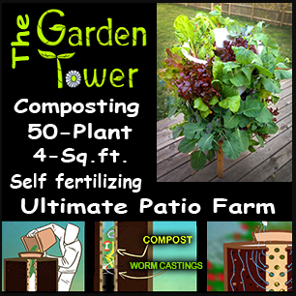

Please understand that The Tower Garden link is an affiliate link, and I will be paid a fee that doesn’t cost you any extra if you purchase.

